TRUCK TYPES BY CLASS
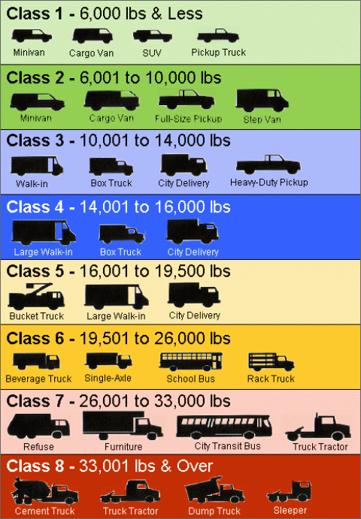
1MW ELECTRICITY DEMAND COMPARISONS
 | Avg Hourly Demand of 1,259 CA Homes
50 Step Vans
(Overnight Charging @ 20kw)
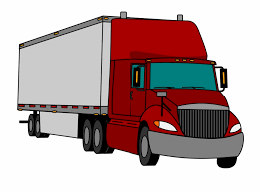 | 4 Class 8 BEV 200-250mi Range Semi-Trucks  (2hr Charge @250kw)
1 Class 8 BEV 200-250mi range Semi-Truck
(30min Charge @1MW)

https://www.eia.gov/electricity/sales_revenue_price/pdf/table5_a.pdf

