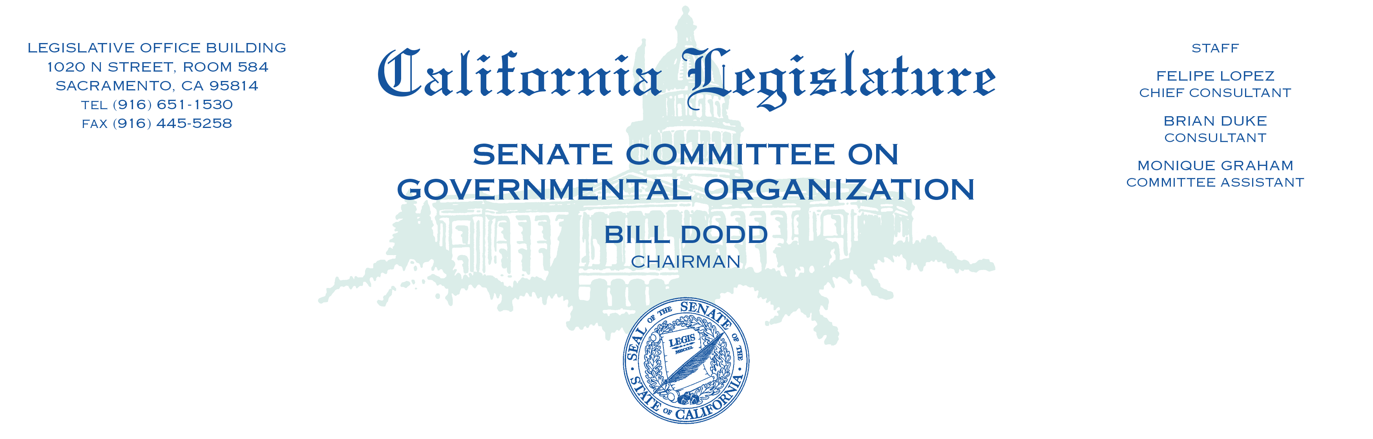

**A G E N D A**

**INFORMATIONAL HEARING**

**SENATE GOVERNMENTAL ORGANIZATION COMMITTEE**

**Tuesday, August 13, 2019**

**9:30 a.m.**

**State Capitol, Room 4203**

**Utilization of Excess State Land for Affordable Housing**

1. **Opening Remarks by Chairman Bill Dodd**
2. **Update on Executive Order N-06-19**

Jason Kenney, Deputy Director of the Real Estate Services Division, Department of General Services

Sasha Wisotsky, Data and Research Manager, Housing Policy at Department of Housing and Community Development

1. **The Role of Local Governments and Affordable Housing Organizations**

John F. Dunbar, Mayor, Town of Yountville & Second Vice President, League of California Cities

David Zisser, Associate Director, Housing California

Pedro Galvao, Senior Policy Manager, Non-Profit Housing Association of Northern California

1. **Public comment**