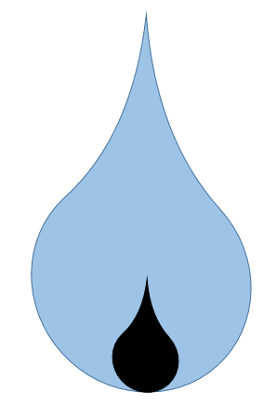
California's Water Challenges in the 21st Century:
Assessing California's Chronically Under Funded Water Needs

Safe and Reliable Drinking Water
Laurel Firestone, Co-Executive Director, Community Water Center

Locals and the state have spent hundreds of billions on water projects since the 1970’s, still hundreds of small, mostly rural systems continue to “fail” in securing safe, accessible and affordable drinking water. This has been a chronic institutional problem long before this current historic drought.

BIG PICTURE:

- 869 systems had MCL violations within the past 5 years
- Of these, the majority were small systems with under 200 connections
- The problem is chronic in at least 296 small community water systems and schools which are unable to supply safe drinking water to their communities for several years or even decades
- Inadequate funding, and/or eligibility restrictions from current funding sources (e.g. Prop. 1) hinder ability to address fundamental water issues and create long-term water sustainability, particularly in small, disadvantaged communities.
- Increasing operations and maintenance costs make water increasingly unaffordable, and current policy (i.e. Prop 218) severely impedes establishment of affordable water programs for low-income ratepayers
- Overall, funding for immediate and long term drinking water projects is in the hundreds of millions, but the need is in the tens of billions.

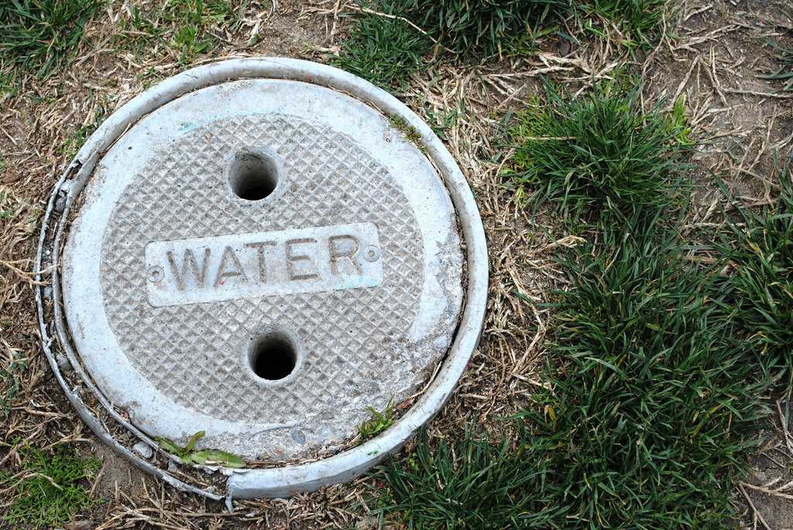

I. Even with Prop 1 and SRF, we do not have the funding available to meet the basic drinking water and wastewater infrastructure needs of disadvantaged communities that do not have the ability to fund those improvements themselves.

Funding Source | Amount Available FY 15-16 | Overall Need
Proposition 1 DW | $260 million
DWSRF | $694 million | $995 million for just SRF
Total | $954 million | $4.6 Billion annually for 10 years  $60 million - $320 million per year.

- Overall, these costs are immense:
  - A Technical Report by University of California Davis estimated that the costs for just nitrate treatment for just the Tulare Lake Basin and Salinas Valley to be between $13.7 and $30.5 million annually, so over 20 years for study area = $650 million - $1.5 billion
  - PPIC’s March 2014 Report, Paying for Water in California estimated the cost to help small DACs under 1,000 connections to be between $30 million and $160 million per year for 20 years, or between $600 million and $3.2 billion annually for 20 years
    - This only includes 215 systems reported to lack safe drinking water.
    - The new report lists 472 small systems lacking safe drinking water
      - Cost to help the 472 systems would be more than double -- well over $60 million - $320 million per year/ or $1.2 billion - $6.4 billion over 20 years

II. Secondly, we currently lack any real funding to address the increasing operations and maintenance costs and the ability to ensure an affordable rate for a basic amount of water. As a result, many of our most disadvantaged households are paying up to 10% of their income for water alone.

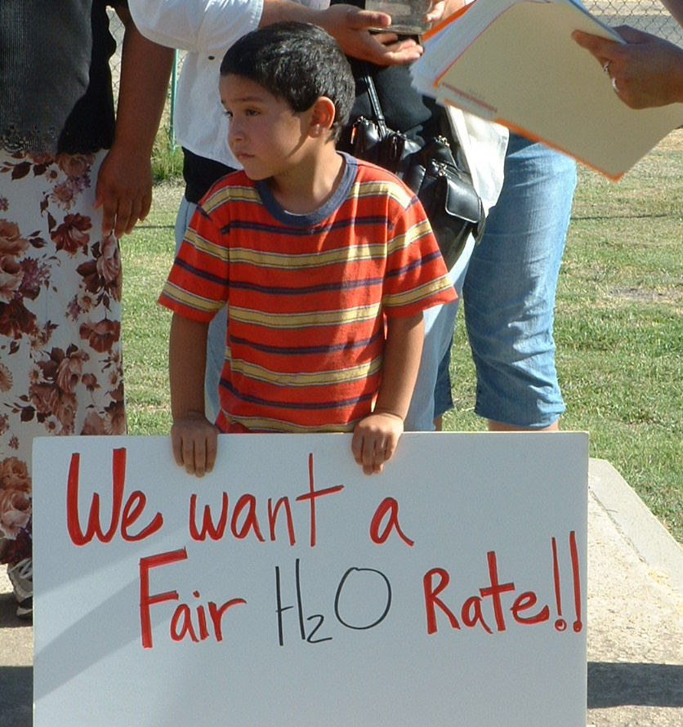
- Groundwater contamination and water scarcity, both exacerbated by the drought, force communities to install expensive treatment systems and pay increasingly costly drinking water just to meet their basic needs.
- Ongoing operations and maintenance costs create additional burden for local ratepayers, to whom costs are regularly transferred.
- This unmet funding need is especially acute in small disadvantaged communities.
  - According to the 2013 Report by PPIC, CWC, and Fresno State University, in the Tulare Lake Basin:
    - 9 (17%) water systems had unaffordable water rates
    - 14 (27%) water systems had unaffordable rates, considering replacement costs
    - 3,933 (29%) households had unaffordable rates
    - 7,021 (51%) households had unaffordable rates, considering replacement costs

Examples:

Community | Issue | Average cost per household | Percent of monthly Income
Alpaugh | Arsenic treatment | $80/month  +$29/month on alternative water supplies | 3.8%  5.2%
Cantua Creek | Trihalomethane, must also purchase bottled water | $100-$170/month  +$29/month on alternative water supplies | 5.3%  6.41%
Porvenir | Purchasing surface water supplies during the drought plus bottled water | $100-$200/month  +$29/month on alternative water supplies | -
Lanare | Covering cost of $1.3 million federal loan for arsenic treatment | $54/month  +$29/month on alternative water supplies | 1.4%  2.2%

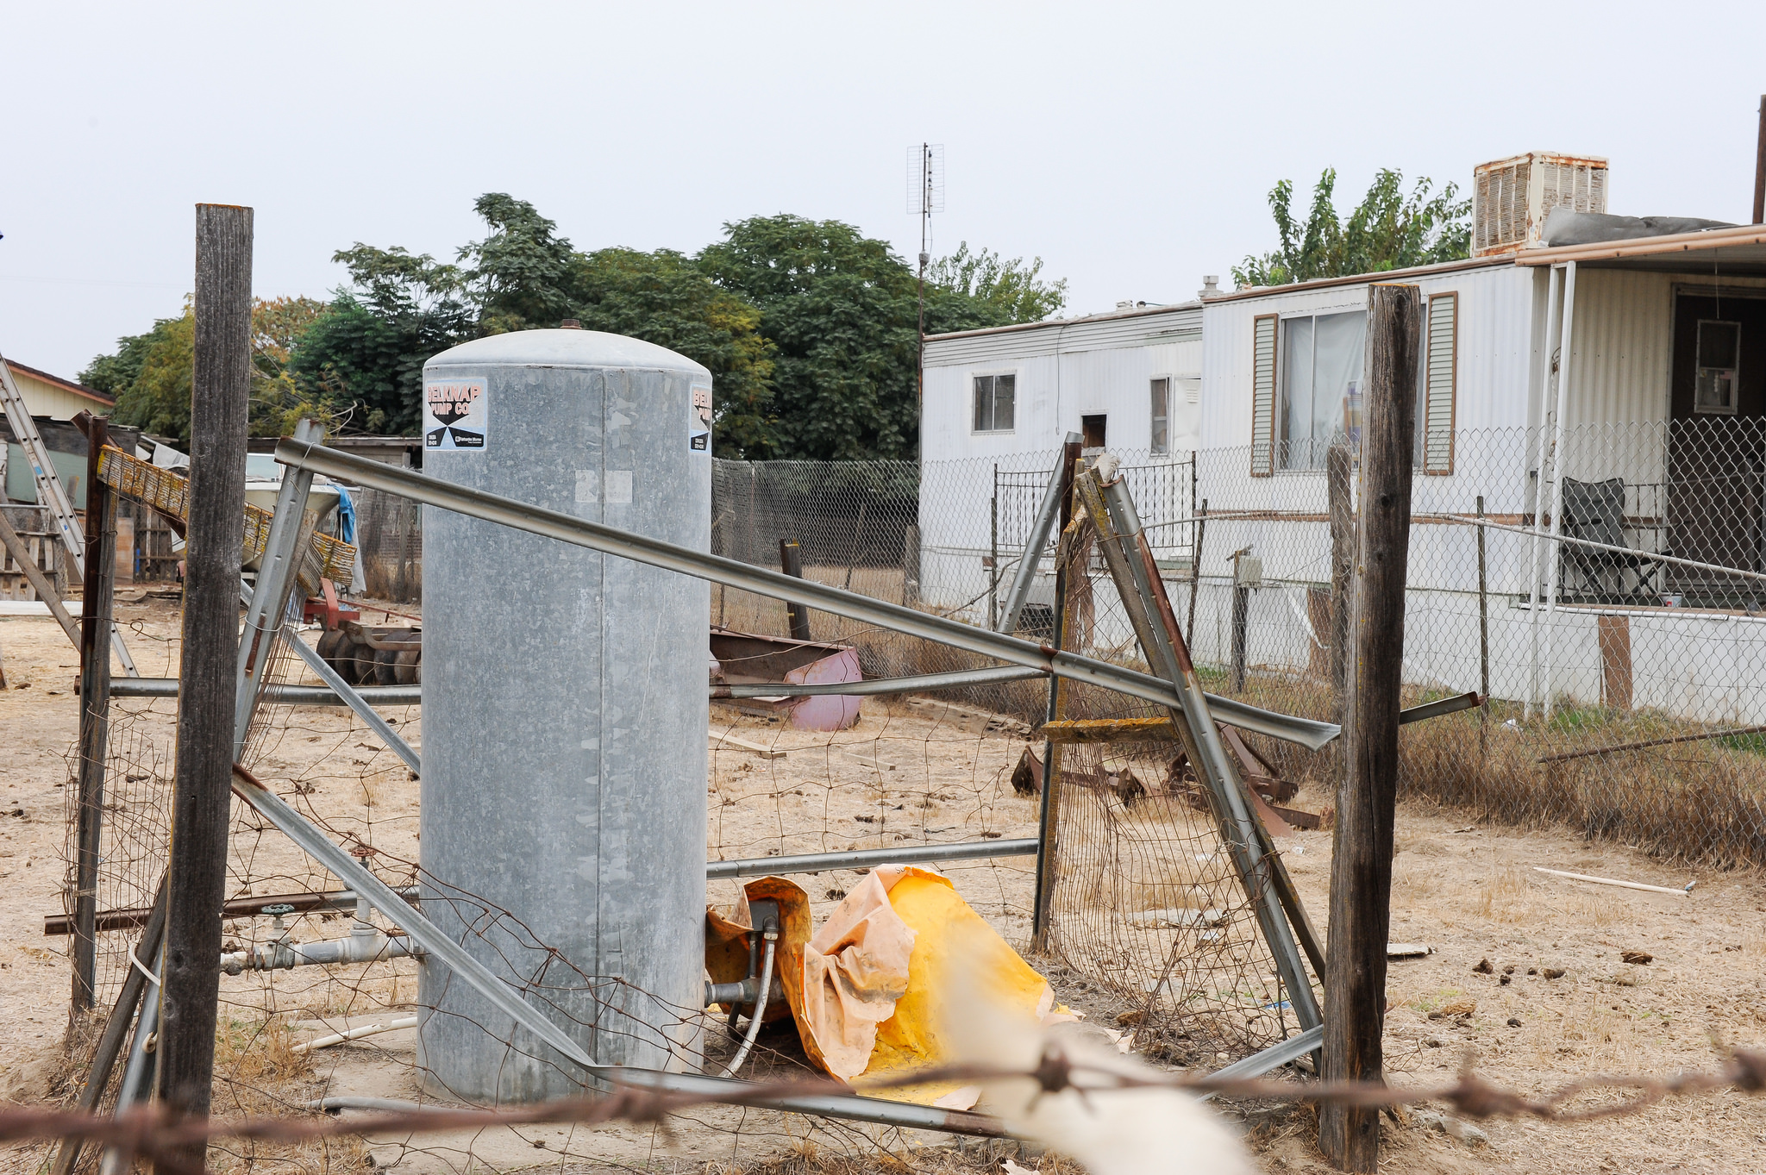

III. State Smalls and Private Wells
After O&M, the largest unfunded need is the drinking water needs for those Californians on state smalls and private wells:

- 2,945 domestic wells have been identified as critical or dry --- impacting nearly 12,000 residents - this is a drastic underestimate.
- Emergency and interim needs continue to be unmet. Permanent resources and focused response from one state department continues to be absent, which further complicates connecting interim solutions with long-term solutions.
  - In 2015 the state committed $24 million to provide emergency drinking water projects ($19 million Clean Up And Abatement & $5 million private wells program under DWR); and there is also limited funding through USDA. Considering one bottled water program in Tulare County costs $500,000 - $ 1 million a year, this funding is extremely limited.
- Existing homes must be able to connect to new water infrastructure, but this is generally not included in traditional infrastructure funding. More is needed to place laterals from small communities to neighboring larger water systems to create long term resilience.
  - Pipe costs on average $1 million per mile.
- Currently there are no state funds for drilling new wells
- Technical assistance and adequate funding are needed to ensure basic coordination and communication issue. Read more about this topic in our Drought Convening Policy Discussion Paper.

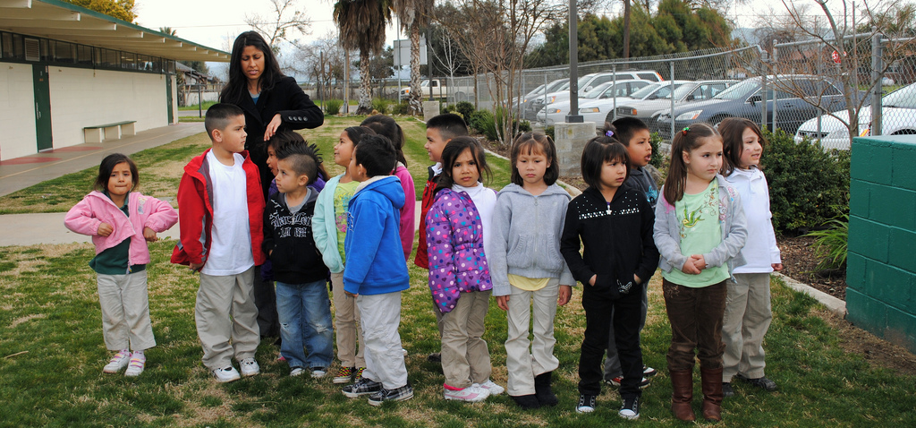

IV. Access Points in Schools and public places
Approximately 25% of California schools are unable to offer access to water during meal times.
- Our preliminary analysis found that nearly 15% of all CA schools received water from a system that was not able to meet the primary MCL - more than 1,400 schools affecting 790,000 students.
    - Over 24,000 children receive unsafe water each day at school from schools which are their own water system.
  - Many communities lack functioning fountains or water “access points” in public places, such as parks.
- This cost of access has not been adequately surveyed to understand the scale of need. However, based on data from the pilot AGUA4ALL initiative, costs may be as high as $126 million just for access points for those schools without safe water. This does not including schools with safe water but dilapidated water fountains.
  - Additional costs associated with access points at schools:
    - Unit of filters costs between $10,000 and $12,000.
    - A sample metric for schools: One access point is required for every 100 - 150 children.
    - For 160 to 240 taps, the estimated cost is between $2 and $3 million.

Recommendations:
- Remove impediments for water agencies to voluntarily implement low-income ratepayer programs and/or “lifeline rates” to qualified customers.
- Create a statewide funding mechanism to support capital infrastructure, treatment, and maintenance costs; and implement more polluter pays mechanisms.
- Invest in transparent data collection and management capacity, particularly for state smalls, private wells, schools, etc.
- Provide funding to implement consolidations and regionalization for small systems
- Prevent land use and permitting patterns that create new unsustainable small water systems or communities reliant on private wells without a secure source.

Derived from a Safe Drinking Water Information System (SDWIS) query of all systems with MCL violations spanning over a 5-year period
The SWRCB maintains a list from SDWIS including only small community public water systems (PWSs) with under 3,300 service connections or a population of less than 10,000 residents, as well as non-community PWS that are schools or day care centers, which have violated state drinking water standards in at least one source in 2014 (ie – at least one MCL violation, at least one treatment violation, or at least one Total Coliform Rule (pathogen) violation). This list does not include state small water systems, which are not regulated by the SWRCB or systems which reported an exceedance of hexavalent chromium MCL in monitoring.
ASCE. $46 billion (over ten years)
Between $600 million and $3.2 billion over 20 years. - This only includes 215 systems; new report lists 472 small systems lacking SDW - Cost for increased systems would more than double -- well over Cost to help small DACs under 1,000 connections = Between $1.2 billion - $6.4 billion over 20 years PPIC Report - Cost of Water
http://groundwaternitrate.ucdavis.edu/files/138956.pdf
http://www.ppic.org/content/pubs/report/R_314EHR.pdf
http://d3n8a8pro7vhmx.cloudfront.net/communitywatercenter/pages/52/attachments/original/1394397950/assessing-water-affordability.pdf?1394397950
http://d3n8a8pro7vhmx.cloudfront.net/communitywatercenter/pages/52/attachments/original/1394397950/assessing-water-affordability.pdf?1394397950
Based on Median Household Income of $25,341 http://factfinder.census.gov/faces/nav/jsf/pages/community_facts.xhtml
Based on Median Household Income of $30,698 http://factfinder.census.gov/faces/nav/jsf/pages/community_facts.xhtml#none
The Median Household Income for Porvenir was unavailable.
Based on Median Household Income of $45,833, http://factfinder.census.gov/faces/nav/jsf/pages/community_facts.xhtml#none

