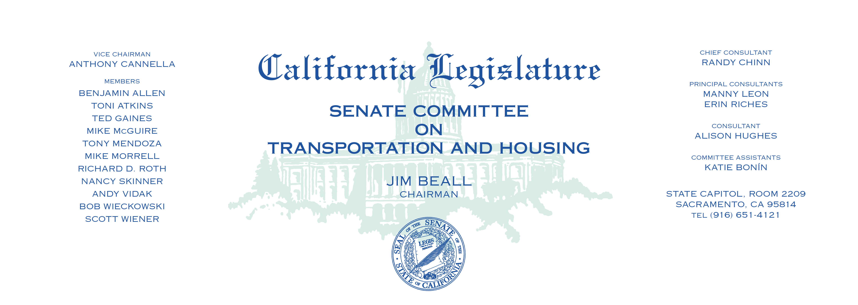

**AGENDA**

Thursday, September 7, 2017

8:30 a.m. —Room 3191

PURSUANT TO SENATE RULE 29.10 (D)

1. SB 797 Hill Peninsula Corridor Joint Powers Board:

transactions and use tax.