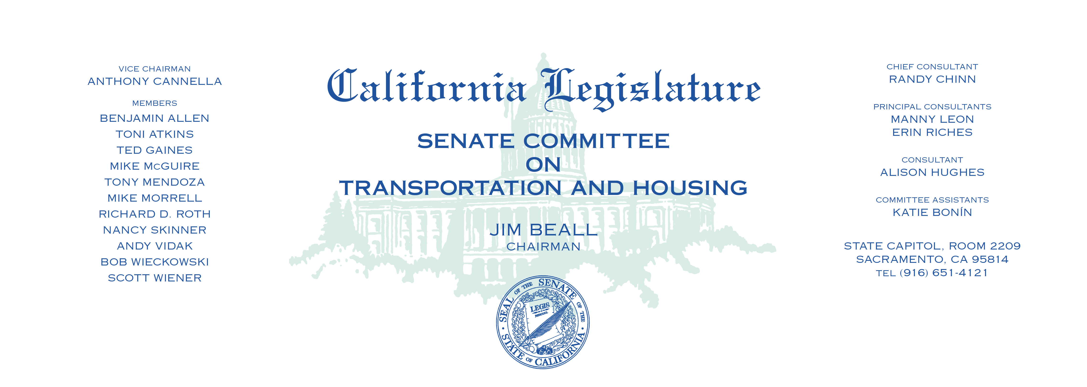

**AGENDA**

Thursday, September 14, 2017

Upon Call of the Chair — Room 2040

PURSUANT TO SENATE RULE 29.10 (D)

1. SB 611 Hill Vehicles.