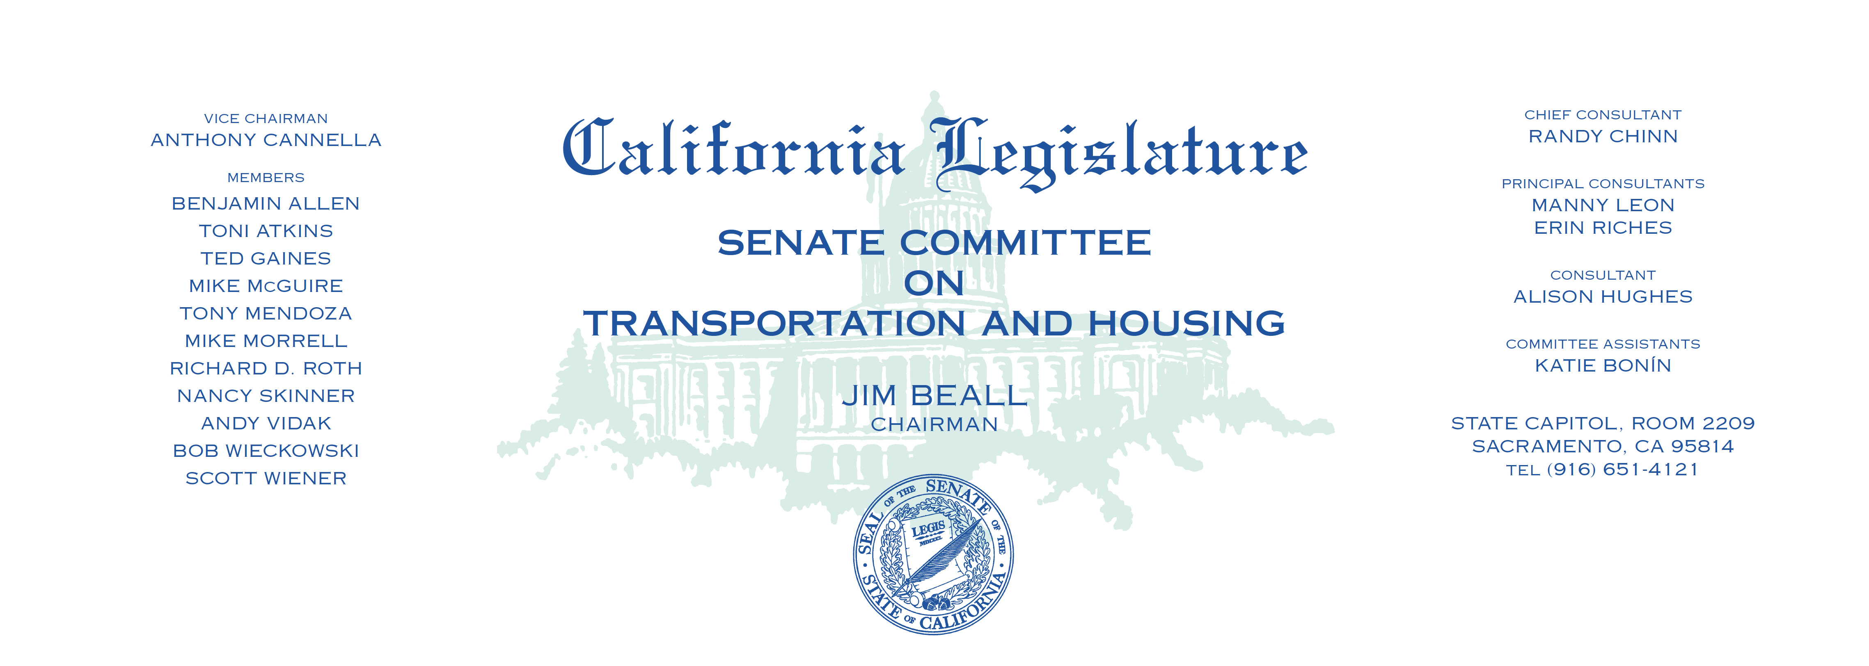

**AGENDA**

Wednesday, September 13, 2017

Upon Call of the Chair — Room 2040

Measures Heard In File Order

1. AB 758 Eggman Transportation: Tri-Valley-San

Joaquin Valley Regional Rail Authority.