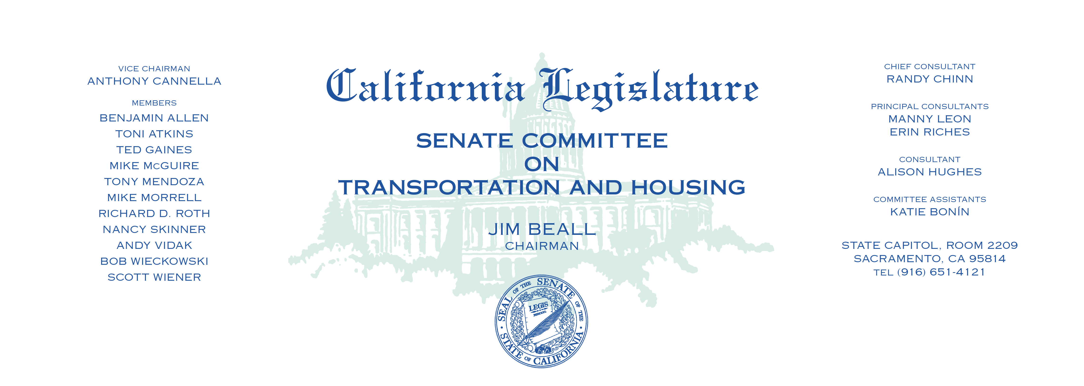

Tuesday, July 11, 2017

1:30 p.m. — John L. Burton Hearing Room (4203)

(PROPOSED CONSENT ITEMS INDICATED WITH *)

**AGENDA**

1. A.C.R. 9* G. Fletcher Officer Jonathan M. De Guzman Memorial Bridge.
2. A.C.R. 22* Baker Detective Sergeant Thomas A. Smith, Jr.

Memorial Highway.

1. A.C.R. 23* Bocanegra Ritchie Valens Memorial Highway.
2. A.C.R 24* Dahle California Highway Patrol Officer Nathan Taylor

Memorial Highway.

1. A.C.R. 29* Dahle Deputy Sheriff Jack Hopkins Memorial Highway.
2. A.C.R. 31* Lackey Los Angeles County Sheriff’s Sergeant Steven C.

Owen Memorial Highway.

1. A.C.R. 43* Wood Humboldt County Sheriff’s Office Corporal

Rich Schlesiger Memorial Highway.

1. A.C.R 46* Gray The Modesto Police Officer Leo Volk, Jr., and

Modesto Police Sergeant Steve May Memorial Highway.

1. A.C.R. 47* Gray CalFire Firefighter Andrew Maloney

Memorial Highway.

1. A.C.R. 49* Frazier Police Sergeant Scott Lunger Memorial Highway.
2. A.C.R. 70* Salas Staff Sergeant Ricardo “Ricky” Barraza Memorial

Highway.

1. A.C.R. 76* Calderon Officer Keith Boyer Memorial Highway.
2. A.C.R. 88* Cunningham Charles I. Walter Memorial Highway.