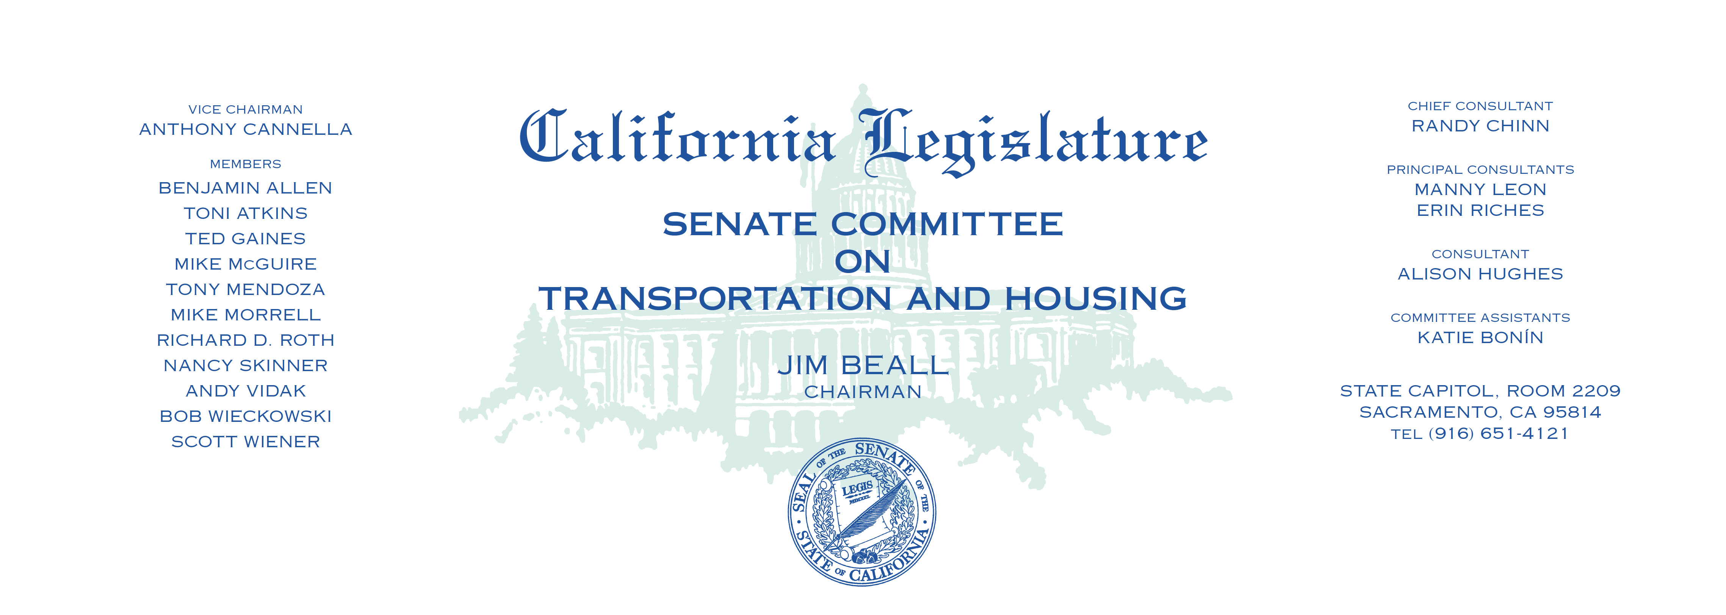

Tuesday, July 11, 2017

1:30 p.m. — John L. Burton Hearing Room (4203)

(PROPOSED CONSENT ITEMS INDICATED WITH *)

**AGENDA**

1. A.B. 758 Eggman Transportation: Tri-Valley-San Joaquin

Valley Regional Rail Authority.

1. A.B. 805 G. Fletcher County of San Diego: transportation agencies.
2. A.B. 857 Ting State highways: property leases.
3. A.B. 964 Calderon Economic development: Capital Access Loan Program:

California Affordable Clean Vehicle Program.

1. A.B. 1069 Low Local government: taxicab transportation services.
2. A.B. 1088 Eggman Multifamily residential housing: energy programs.
3. A.B. 1222 Quirk Vehicles: electronic wireless communications devices.
4. A.B. 1239 Holden Building standards: electric vehicle charging

infrastructure.

1. A.B. 1397 Low Local planning: housing element:

inventory of land for residential development.

1. A.B. 1407 McCarty California New Motor Voter Program: voter registration.
2. A.B. 1515 Daly Planning and zoning: housing.
3. A.B. 1521 Bloom Land use: notice of proposed change:

assisted housing developments.

1. A.B. 1598 Mullin Affordable housing authorities.
2. A.B. 1625 Rubio Inoperable parking meters.
3. A.C.R. 2* Mayes Police Officer Jose “Gil” Vega and Police Officer

Lesley Zerebny Memorial Highway.