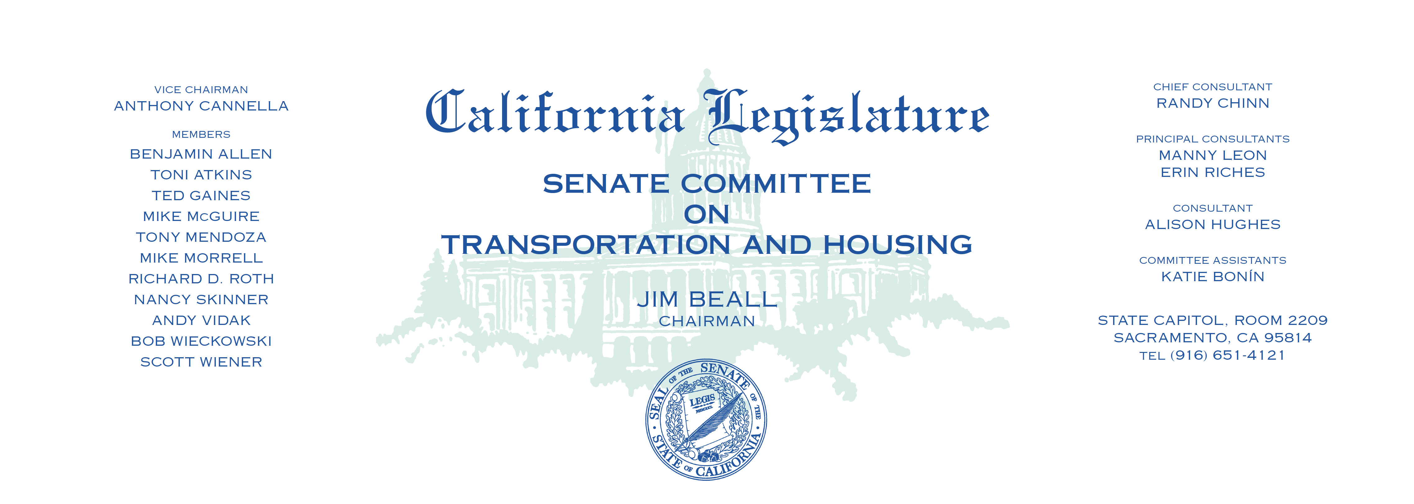

Tuesday, July 11, 2017

1:30 p.m. — John L. Burton Hearing Room (4203)

(PROPOSED CONSENT ITEMS INDICATED WITH *)

**AGENDA**

1. S.B. 159 Allen Off-highway Vehicles.
2. A.B. 17 Holden Transit Pass Pilot Program: free or

reduced-fare transit passes.

1. A.B. 63 Frazier Driver’s licenses: provisional licenses.
2. A.B. 72 Santiago Housing.
3. A.B. 91 Cervantes High-occupancy vehicle lanes.
4. A.B. 174 Bigelow California Transportation Commission: membership.
5. A.B. 179 Cervantes California Transportation Commission.
6. A.B. 301 Rodriguez Commercial motor vehicles: examination requirements:

driving skills test.

1. A.B. 344 Melendez Toll evasion violations.
2. A.B. 390 Santiago Pedestrian crossing signals.
3. A.B. 458* Frazier Vehicle registration: fleet vehicles.
4. A.B. 503 Lackey Vehicles: parking violations:

registration or driver’s license renewal.

1. A.B. 533 Holden State Highway Route 710.
2. A.B. 544 Bloom Vehicles: high-occupancy vehicle lanes.
3. A.B. 615 Cooper Air Quality Improvement Program: Clean Vehicle Rebate

Project.

1. A.B. 630 Cooper Vehicles: retirement and replacement.
2. A.B. 669* Berman Department of Transportation: motor vehicle

technology testing.