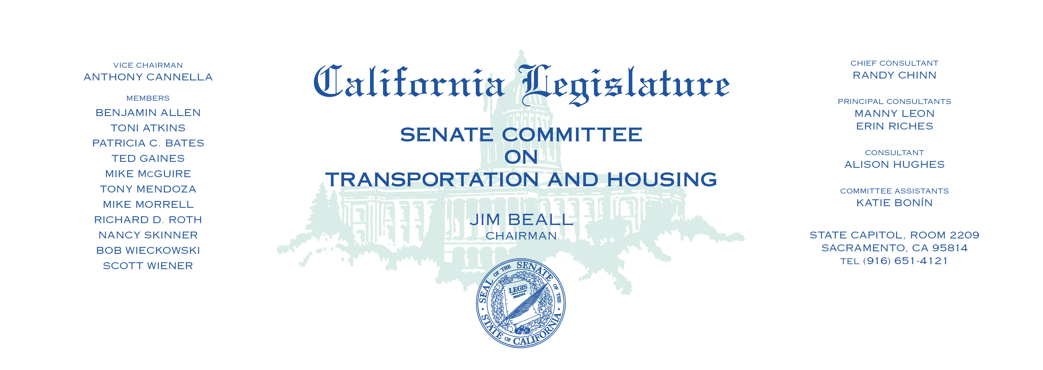

Tuesday, June 6, 2017

1:30 p.m. — John L. Burton Hearing Room (4203)

(PROPOSED CONSENT ITEMS INDICATED WITH *)

**AGENDA**

**VOTE FOR RECONSIDERATION ONLY**

1. S.B. 712 Anderson Vehicles: license plate covers.

**MEASURES HEARD IN FILE ORDER**

1. A.B. 332* Bocanegra Vehicles: local regulations: street closures.
2. A.B. 346* Daly Redevelopment: housing successor:

Low and Moderate Income Housing Asset Fund.

1. A.B. 352* Santiago State Housing Law: efficiency units.
2. A.B. 690* Quirk-Silva Common interest developments: managers:

conflicts of interest.

1. A.B. 695* Bocanegra Avoidance of on-track equipment.
2. A.B. 790 Stone Identification cards: replacement: reduced fee.
3. A.B. 1027 Acosta Driver’s licenses: examinations: motorcycle licenses.
4. A.B. 1113* Bloom State Transit Assistance program.
5. A.B. 1137* Maienschein Housing developments: pet permissibility.
6. A.B 1303* McCarty Vehicles: window tinting.
7. A.B. 1505 Bloom Land use: zoning regulations.