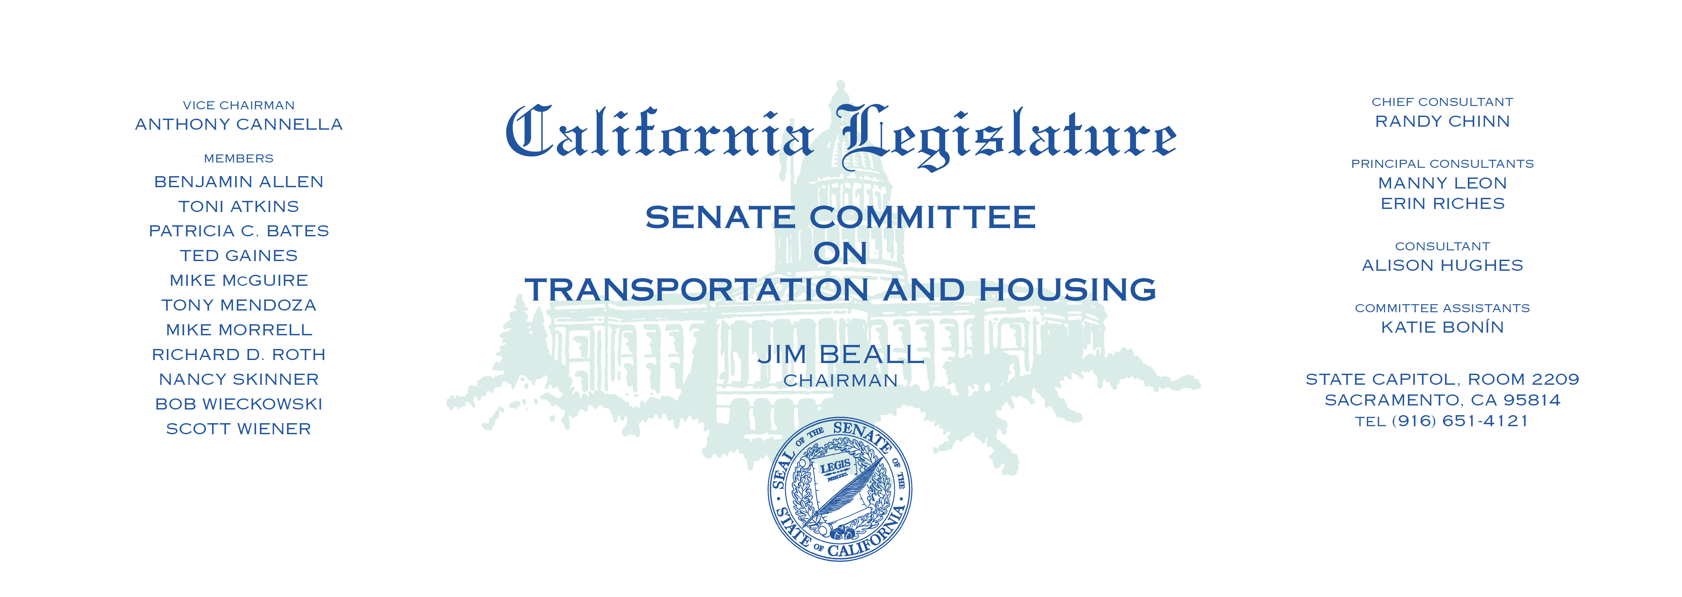

Tuesday, June 27, 2017

1:30 p.m. — John L. Burton Hearing Room (4203)

(PROPOSED CONSENT ITEMS INDICATED WITH *)

**AGENDA**

1. A.B. 697 Fong Tolls: exemption for privately owned emergency

ambulances.

1. A.B. 866* Cunningham State highways: gateway monuments.
2. A.B. 1094* Choi Vehicles: automated traffic enforcement systems.
3. A.B. 1127 Calderon Baby diaper changing stations.
4. A.B. 1274 O’Donnell Smog check: exemption.
5. A.B. 1282* Mullin Transportation Permitting Taskforce.
6. A.B. 1317 Gray Carl Moyer Memorial Air Quality Standards

Attainment Program.

1. A.B. 1444 Baker Livermore Amador Valley Transit Authority:

demonstration project.

1. A.B. 1613 Mullin San Mateo County Transit District:

retail transactions and use tax.

1. A.B. 1633* Frazier State highways: exit information signs.
2. A.B. 1714* Committee on Housing and Community Development

Income taxes: credits: low-income housing: farmworker housing: building standards: housing and home finance.