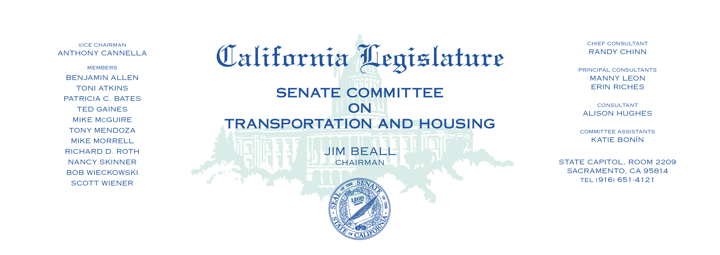

Tuesday, June 20, 2017

1:30 p.m. — John L. Burton Hearing Room (4203)

(PROPOSED CONSENT ITEMS INDICATED WITH *)

**AGENDA**

**Page #2**

**_____________________________________________________**

|  |  |  |  |
| --- | --- | --- | --- |
| 12. | AB 1172* | Acosta | State highways: relinquishment. |
| 13. | AB 1393 | Friedman | Reckless driving: speed contests: vehicle impoundment. |
| 14. | AB 1523* | Obernolte | San Bernardino County Transportation  Authority: design-build. |
| ~~15.~~ | ~~AB 1625~~ | ~~Rubio~~ | ~~Inoperable parking meters.~~ |
| 16. | AJR 4 | Cervantes | Home Ownership. |
|  |  |  |  |