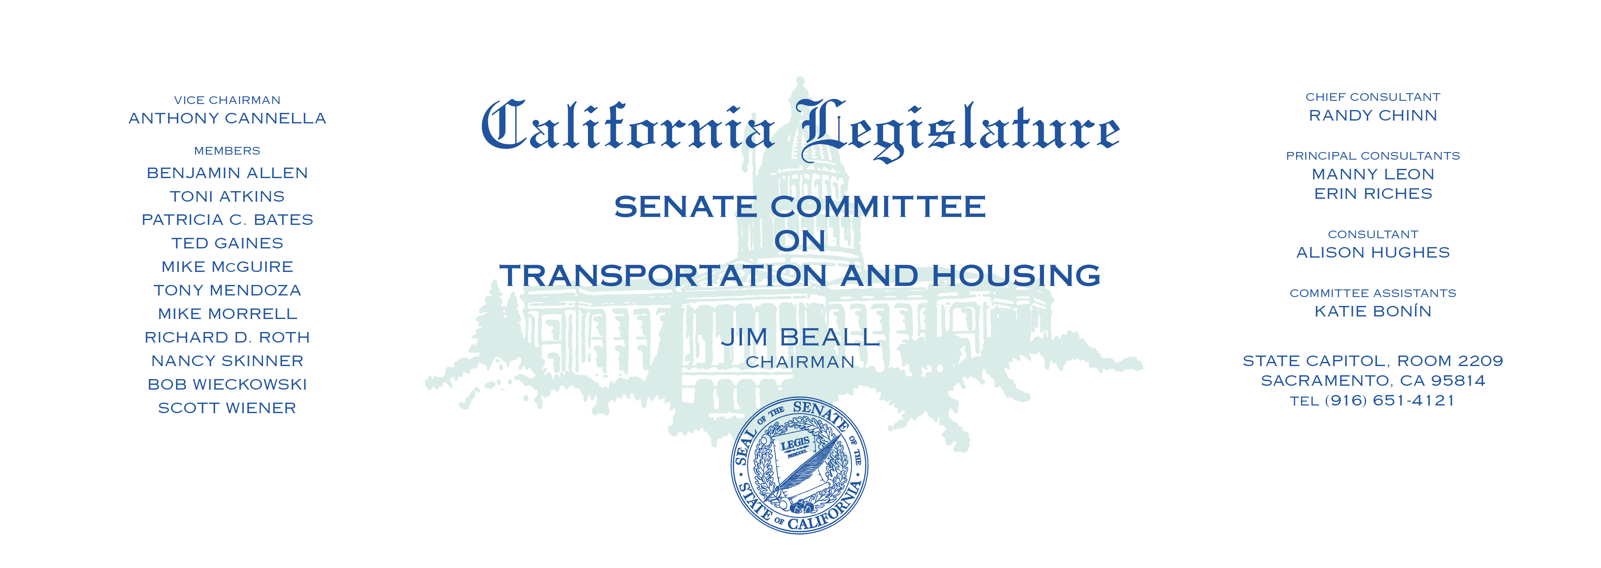

Tuesday, June 20, 2017

1:30 p.m. — John L. Burton Hearing Room (4203)

(PROPOSED CONSENT ITEMS INDICATED WITH *)

**AGENDA**

**_____________________________________________________**

|  |  |  |  |
| --- | --- | --- | --- |
| 1. | AB 333* | Quirk | State Highway Route 185: relinquishment: County of Alameda. |
| 2. | AB 363* | Quirk-Silva | Driver’s licenses: veteran designation. |
| 3. | AB 381 | Calderon | Vehicle registration: Voluntary Deaf or Hard of Hearing Notification Program: establishment. |
| 4. | AB 467 | Mullin | Local transportation authorities: transactions and use taxes. |
| 5. | AB 468 | Santiago | Transit districts: prohibition orders. |
| 6. | AB 494* | Bloom | Land use: accessory dwelling units. |
| 7. | AB 678 | Bocanegra | Housing Accountability Act. |
| 8. | AB 696 | Caballero | Department of Transportation: Prunedale Bypass: County of Monterey: disposition of excess properties. |
| 9. | AB 863* | Cervantes | Affordable Housing and Sustainable Communities Program. |
| 10. | AB 932 | Ting | Shelter crisis: homeless shelters and permanent supportive housing. |
| 11. | AB 1086 | Daly | Housing: regional housing needs. |
| 12. | AB 1172 | Acosta | State highways: relinquishment.  (1, Fiscal) |
| 13. | AB 1393 | Friedman | Reckless driving: speed contests: vehicle impoundment.  (1, LOC. Man., Fiscal) |