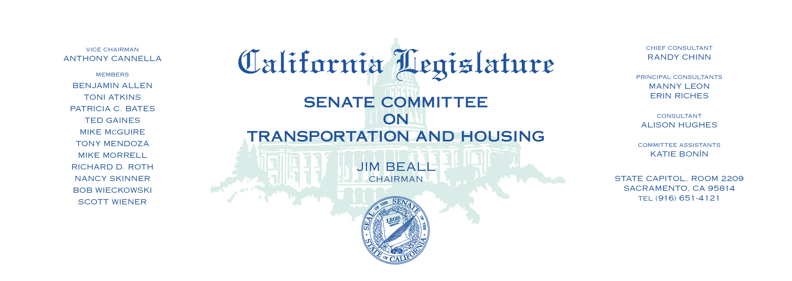

Tuesday, June 13, 2017

1:30 p.m. — John L. Burton Hearing Room (4203)

(PROPOSED CONSENT ITEMS INDICATED WITH *)

**AGENDA**

**_____________________________________________________**

1. A.B. 56 Holden California Infrastructure and Economic

Development Bank: housing.

1. A.B. 673 Chu Public transit operators: bus procurement:

safety considerations.

1. A.B. 730* Quirk Transit districts: prohibition orders.
2. A.B. 810* Gallagher Local alternative transportation improvement program:

Feather River crossing.

1. A.B. 879* Grayson Planning and zoning: housing element.
2. A.B. 1073 E. Garcia California Clean Truck, Bus, and Off-Road Vehicle

and Equipment Technology Program.

1. A.B. 1189 E. Garcia Riverside County Transportation Commission:

transactions and use tax.

1. A.B. 1338* Low Vehicles: specialized license plates.
2. A.B. 1393 Friedman Reckless driving: speed contests: vehicle impoundment.
3. A.B. 1412* Choi Common interest developments: notices:

volunteer officers: liability.

1. A.B 1452 Muratsuchi Parking: exclusive electric charging and parking

on public streets.

1. SCR 56* Anderson Historic Highway Route 67.