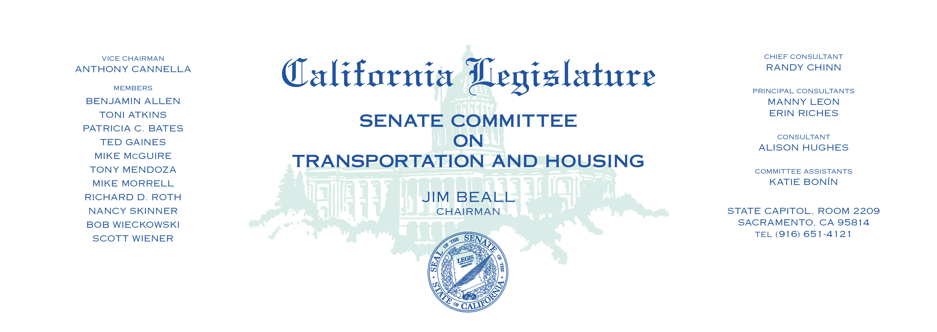

Tuesday, May 9, 2017

1:30 p.m. — John L. Burton Hearing Room (4203)

(PROPOSED CONSENT ITEMS INDICATED WITH *)

**AGENDA**

**_____________________________________________________**

1. S.B. 71 Wiener Electricity: solar energy systems.
2. S.B. 268 Mendoza Los Angeles County Metropolitan Transportation

Authority.

1. S.B. 622* Wiener Local Agency Public Construction Act: Golden Gate

Bridge, Highway and Transportation District.

1. S.B. 712 Anderson Vehicles: license plate covers.
2. SCA 6 Wiener Local transportation measures: special taxes: voter

approval.

1. SCR 46* Gaines Thomas J. Cosgrove Memorial Bypass.