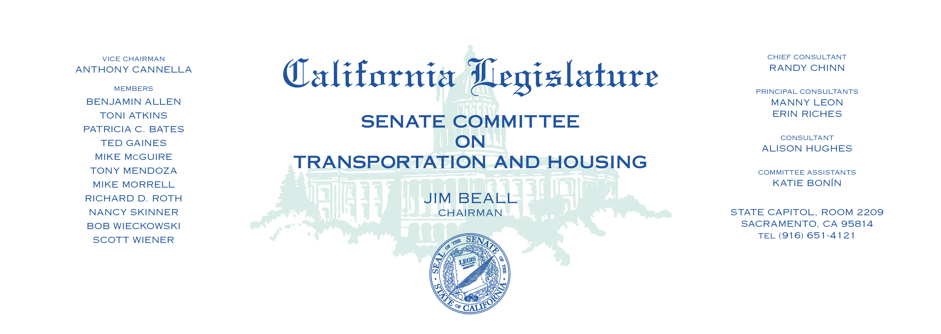

Tuesday, April 4, 2017

1:30 p.m. — John L. Burton Hearing Room (4203)

**AGENDA**

**_____________________________________________________**

1. S.B. 65 Hill Vehicles: alcohol and marijuana: penalties.
2. S.B. 158 Monning Commercial driver’s license: education.
3. S.B. 167 Skinner Housing Accountability Act.
4. S.B. 179 Atkins Gender identity: female, male, or nonbinary.
5. S.B. 185 Hertzberg Vehicles: violations.
6. S.B. 347 Jackson State Remote Piloted Aircraft Act.
7. S.B. 362 Galgiani Department of Motor Vehicles: records: confidentiality.
8. S.B. 414 Vidak Transportation bonds: highway, street, and

road projects.

1. S.B. 415 Vidak High-speed rail: rights-of-way.
2. S.B. 498 Skinner Vehicle fleets: zero-emission vehicles.
3. S.B. 540 Roth Workforce Housing Opportunity Zone.
4. S.B. 587 Atkins Emergency vehicles: blue warning lights.
5. S.B. 699 Galgiani Vehicles: removal and impoundment.