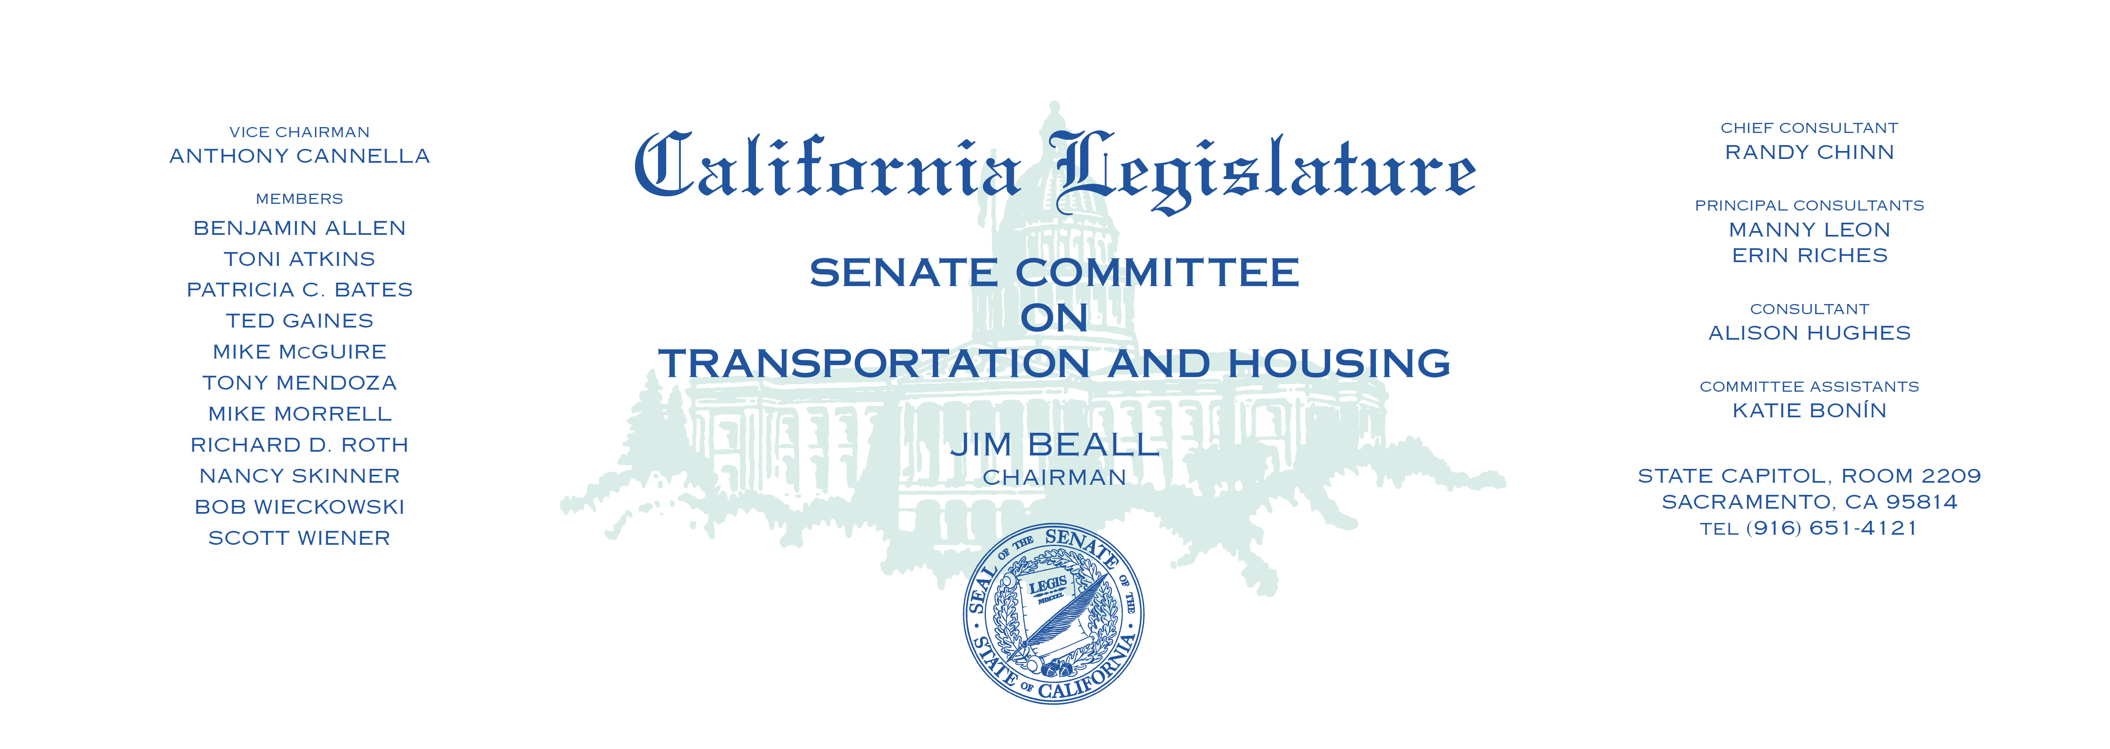

Tuesday, April 25, 2017

1:30 p.m. — John L. Burton Hearing Room (4203)

(PROPOSED CONSENT ITEMS INDICATED WITH *)

(PROPOSED CONSENT ITEMS WITH AMENDMENTS INDICATED WITH **)

**AGENDA**

**_____________________________________________________**

1. S.B. 673* Newman Pet Lover’s specialized license plates.
2. S.B. 682 Nielsen Online voter registration.
3. S.B. 721 Hill Contractors: decks and balconies: inspection.
4. S.B. 744 Hueso Outdoor advertising: exemption.
5. S.B. 750 Hueso Vehicles: Digital license plates.
6. S.B. 768 Allen Transportation projects: comprehensive development

lease agreements.

1. S.B. 810* T. & H. Transportation: omnibus bill.
2. SCR 8 Portantino President Barack H. Obama Highway.
3. SCR 25* Portantino State highways: Pasadena Armenian Genocide Memorial.