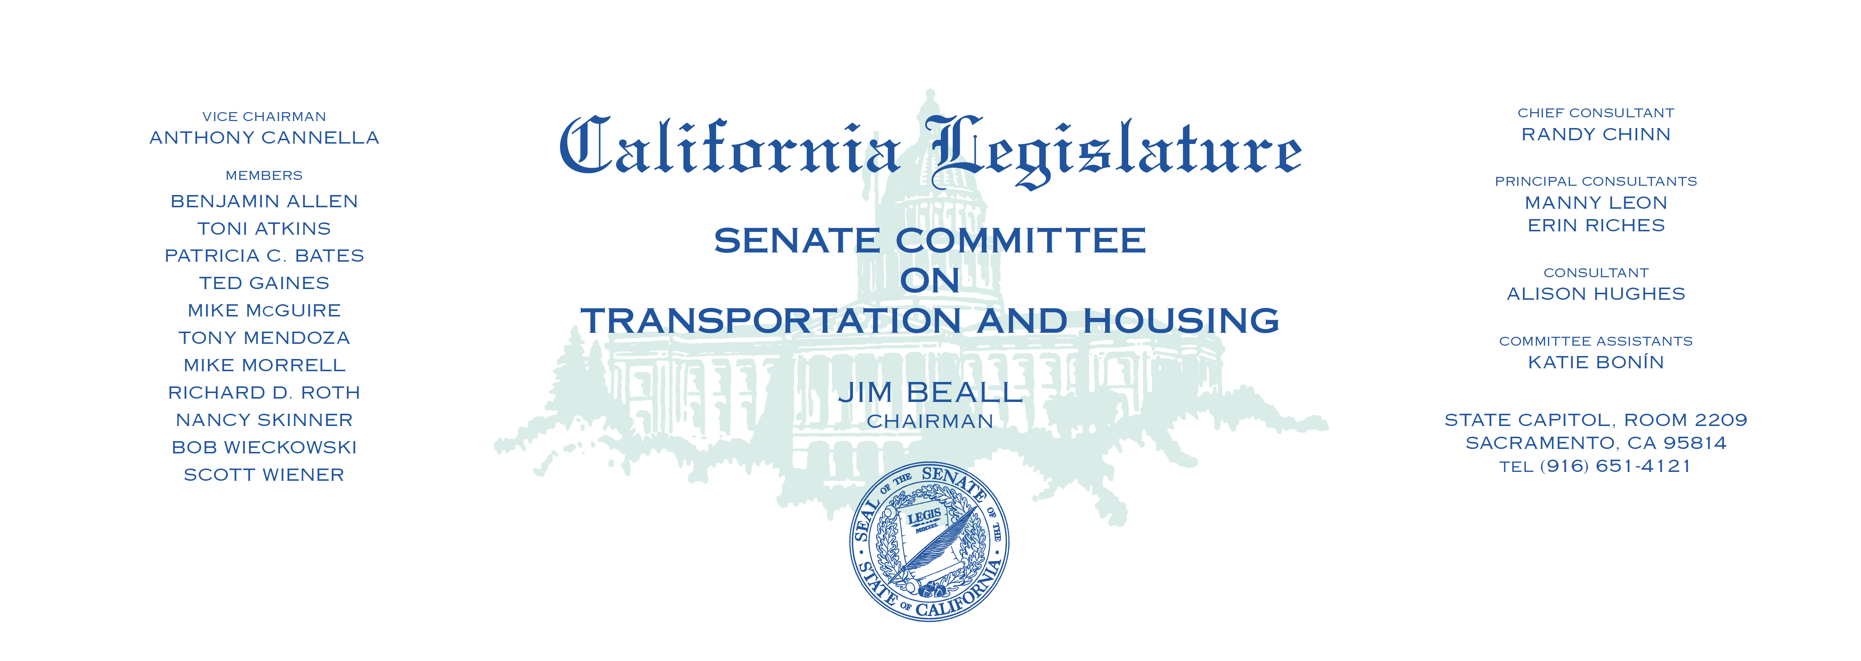

Tuesday, April 25, 2017

1:30 p.m. — John L. Burton Hearing Room (4203)

(PROPOSED CONSENT ITEMS INDICATED WITH *)

(PROPOSED CONSENT ITEMS WITH AMENDMENTS INDICATED WITH **)

**AGENDA**

1. S.B. 137 Allen Transit districts: ordinances.
2. S.B. 150 Allen Regional transportation plans.
3. ~~S.B. 264 Nguyen High-occupancy toll lanes: Interstate 405 Improvement~~

~~Project high-occupancy toll lanes.~~

1. S.B. 305 Skinner Housing: code compliance: low-interest loans.
2. S.B. 309 Jackson License plates: Reproductive Freedom Fund.
3. S.B. 400** Portantino Highways: victim memorial signs.
4. S.B. 405 Mendoza Outdoor advertising displays: exemptions: City of Artesia.
5. S.B. 406 Leyva Vehicles: high-occupancy vehicle lanes: exceptions.
6. ~~S.B. 459 Portantino Outdoor advertising displays: City of Upland.~~
7. S.B. 477* Cannella Intercity rail corridors: extensions.
8. S.B. 480 Hueso Bridge safety projects: State Highway Account: funding.
9. ~~S.B. 578 Glazer Highways: Safety Enhancement-Double Fine Zone.~~
10. S.B 595 Beall Metropolitan Transportation Commission: toll bridge

revenues.