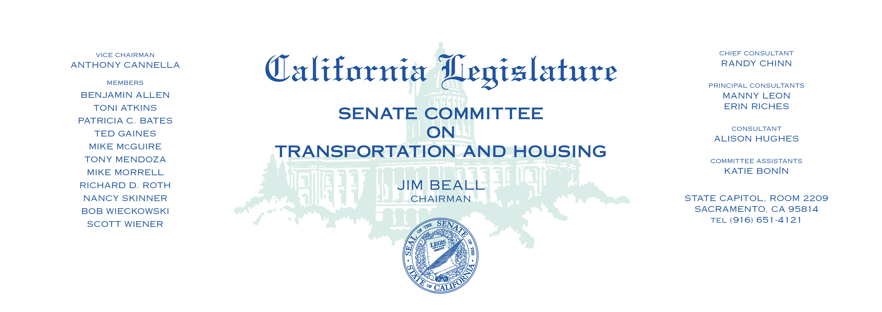

Tuesday, April 18, 2017

1:30 p.m. — John L. Burton Hearing Room (4203)

*Items on consent

**AGENDA**

1. S.B. 46* Leyva Mobilehomes: enforcement actions: sunset provision.
2. S.B. 53 Hueso Natural gas vehicles.
3. S.B. 62* Jackson Affordable Senior Housing Act of 2017.
4. S.B. 136 Leyva Mobilehome parks: mobilehome park program funding.
5. S.B. 145* Hill Autonomous vehicles: testing on public roads.
6. S.B. 167 Skinner Housing Accountability Act.
7. S.B. 249 Allen Off-highway motor vehicle recreation.
8. S.B. 277 Bradford Land use: zoning regulations.
9. S.B. 329 Leyva Manufactured homes: financial assistance programs.
10. S.B. 362 Galgiani Department of Motor Vehicles: records: confidentiality.
11. S.B. 389 Roth Department of Transportation: programmatic

testing and inspection services.

1. S.B. 442* Newman Public health: pools: drownings.
2. S.B. 493 Hill Vehicles: right-turn violations.
3. S.B. 614 Hertzberg Public transportation agencies: administrative

penalties.

1. S.B. 672* Fuller Traffic-actuated signals: motorcycles and bicycles.
2. S.B. 680 Wieckowski San Francisco Bay Area Rapid Transit District.
3. S.B. 802 Skinner Autonomous vehicles: registration.