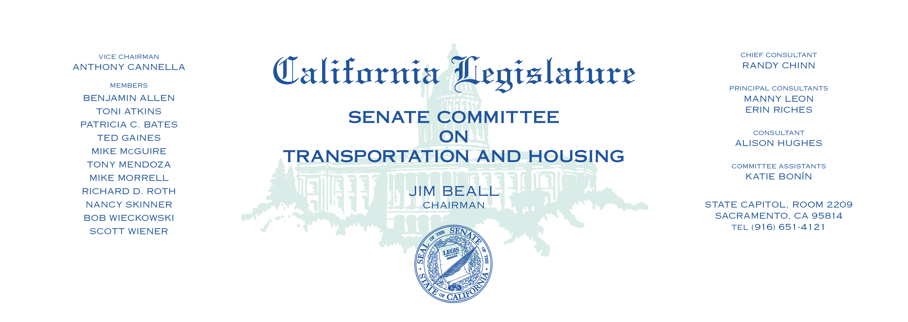

**Bills Heard in File Order**

**_____________________________________________________**

1. S.B. 4 Mendoza Goods Movement: allocation of federal funds:

Goods Movement and Clean Trucks Bond Act.

1. S.B. 35 Wiener Planning and Zoning: affordable housing:

streamlined approval process.

1. S.B. 166 Skinner Residential density and affordability.