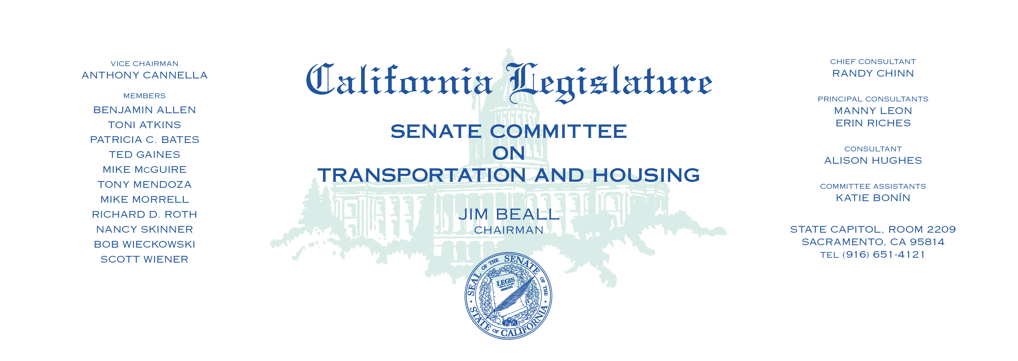

Tuesday, March 14, 2017

1:30 p.m. — John L. Burton Hearing Room (4203)

**Bills Heard in File Order**

**_____________________________________________________**

1. S.C.A. 2 Newman Motor vehicle fees and taxes: restriction on

expenditures.