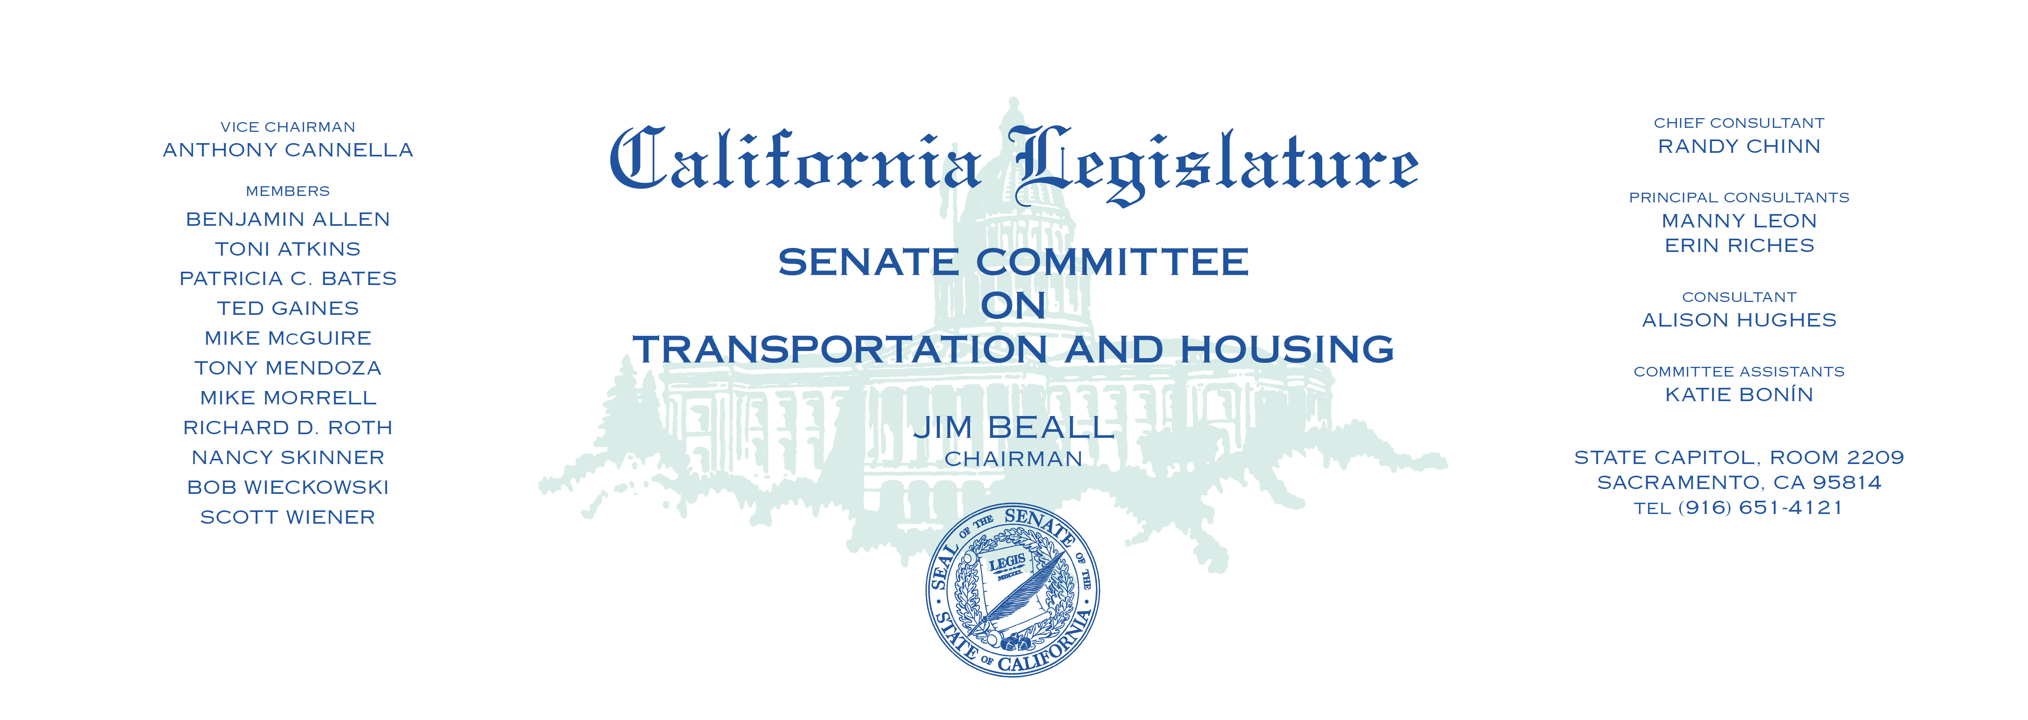

Tuesday, March 28, 2017

1:30 p.m. — John L. Burton Hearing Room (4203)

**AGENDA**

**_____________________________________________________**

1. S.B. 20 Hill Vehicles: buses: seatbelts.
2. S.B. 174 Lara Diesel-fueled vehicles: registration.
3. S.B. 229 Wieckowski Accessory dwelling units.
4. S.B. 275 Portantino Surplus residential property: State Route 710:

property taxes: assessments. (Tax Levy)

1. S.B. 330 Berryhill Building permit fees: waiver.
2. S.B. 542 Leyva Manufactured Housing Act of 1980:

notice of transfer and release of liability.

1. S.B. 660 Newman Vehicle exhaust systems: exemption.
2. S.B. 680 Wieckowski San Francisco Bay Area Rapid Transit District.