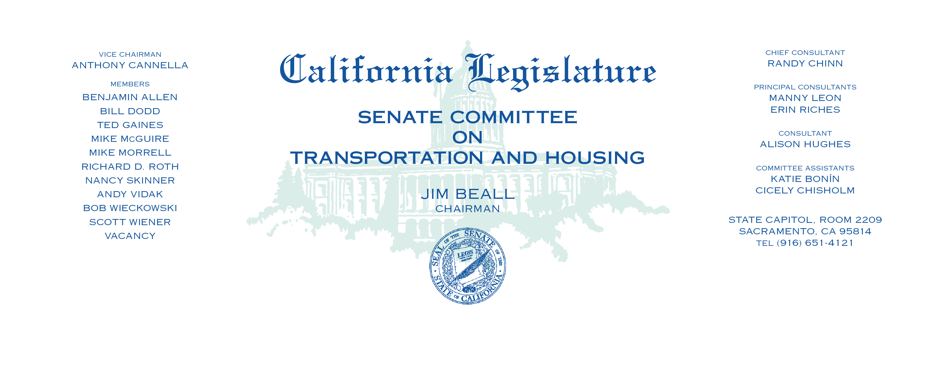

Tuesday, March 20, 2018

1:30 p.m. — John L. Burton Hearing Room (4203)

Items on consent are indicated by *

**AGENDA**

**_____________________________________________________**

1. S.B. No. 1016 Allen. Common interest developments: EV-dedicated

TOU meters.

1. S.B. No. 1172* Beall. High-Speed Rail Authority.
2. S.B. No. 1173* Vidak. Common interest developments: annual notices.
3. S.B. No. 1236* Monning. Commercial driver’s license: education.