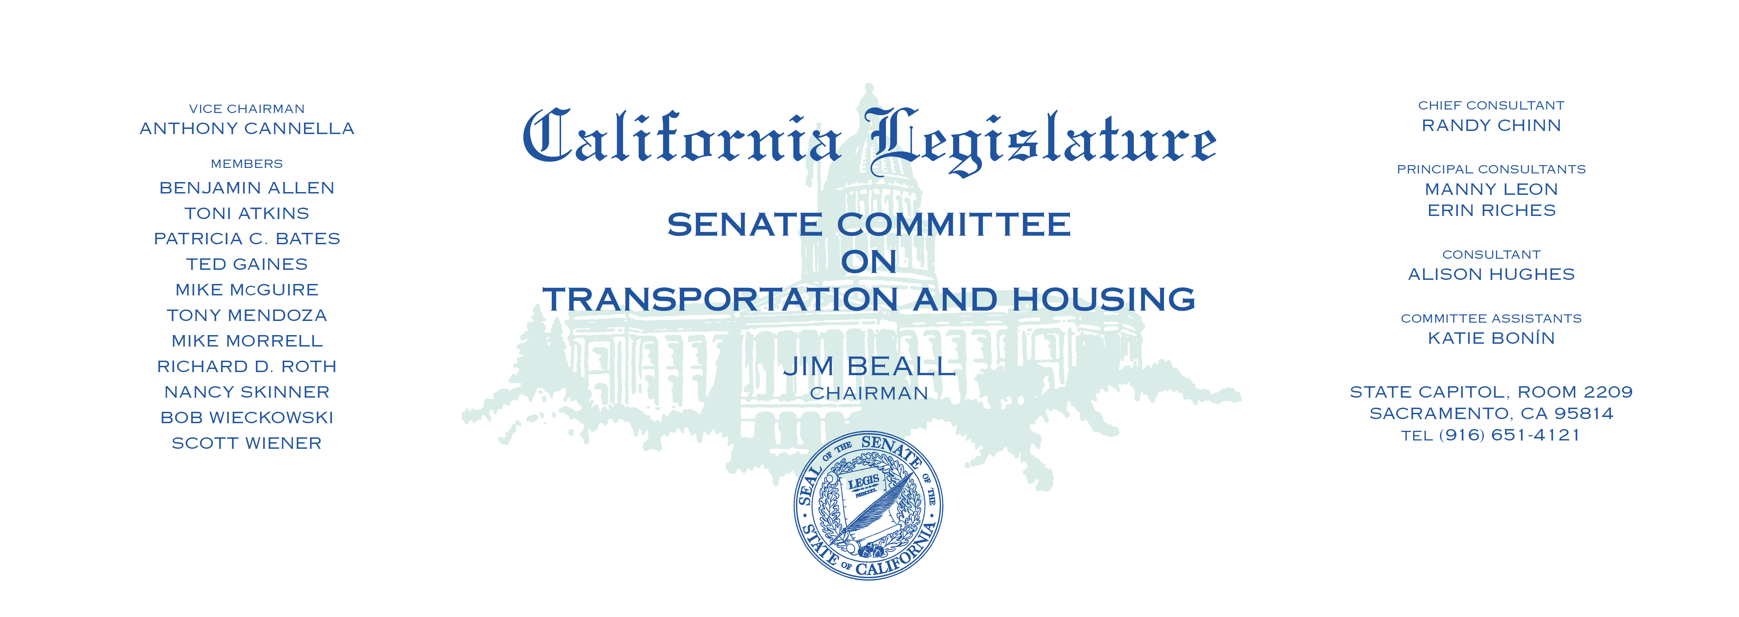

**INFORMATIONAL HEARING**

**SENATE TRANSPORTATION AND HOUSING**

**COMMITTEE**

**High-Speed Rail: Where are we now and where are we heading?**

Tuesday, March 14, 2017

1:30 p.m. — John L. Burton Hearing Room (4203)

**AGENDA**

________________________________________________________________________

1. **Opening Remarks**

* Senator Jim Beall, *Chair,* Senate Transportation and Housing Committee

1. **Delivering Sustainable High-Speed Rail**

* Dan Richard, Chairman, California High-Speed Rail Authority
* Jeff Morales, Chief Executive Officer, California High-Speed Rail Authority
* Oliver Baines, Council Member, City of Fresno
* Curtis Lovett, Owner, Outback Materials
* Dr. Vida Wright, P.E., Managing Principal, Veridico Group

1. **Funding and Managing Risk**

* Dan Richard, Chairman, California High-Speed Rail Authority
* Jeff Morales, Chief Executive Officer, California High-Speed Rail Authority
* Lou Thompson, Chair, California High-Speed Rail Peer Review Group

1. **Regional Investments**

* Liria Larano, Deputy Chief Officer, Caltrain Modernization Program
* Roderick Diaz**,** Director, Planning & Development, Metrolink

1. **Public Comment**
2. **Closing Remarks**