Fact Sheet: Homelessness in California

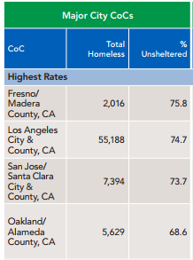
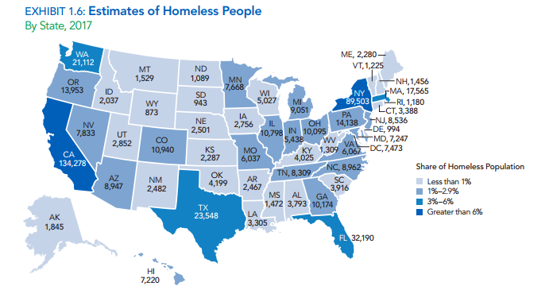

Total Homeless People on a Single Night in January 2017:
- California had 134,278 homeless people, which accounted for 25% of the nation’s homeless population. California also had the highest rate of unsheltered people at 68.2% (91,642 were unsheltered).
- California experienced the largest increase in the number of people experiencing homelessness from 2016 at 16,136 people.
- In four states, more than half of all people experiencing homelessness lived in unsheltered locations: California (68%), Nevada (58%), Oregon (57%), and Hawaii (53%).

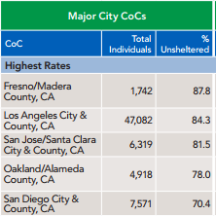
Total Homeless Individuals on a Single Night in January 2017:
- California had 112,756 homeless individuals, which accounted for 31% of the nation’s population. California had the highest rate of unsheltered homeless individuals at 77.8% (87,743 were unsheltered).
- California experienced an increase 15,096 homeless individuals since 2016.
- California possesses 5 of the top major city Continuums of Care (CoC’s) with the highest rate of unsheltered homeless individuals.

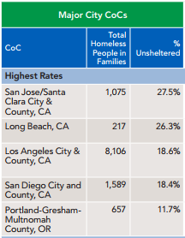
Total Homeless Families on a Single Night in January 2017:
- California had 21,522 families with children experiencing homelessness, which accounts for 16% of the state’s homeless family population.
- Though California experienced an increase between 2016 and 2017, the number of people in families with children was considerably lower in 2017 than it was in 2007 (by 6,512 people or 23%).
- California possesses 4 of the top 5 major city CoC’s with the highest rate of unsheltered homeless families with children.
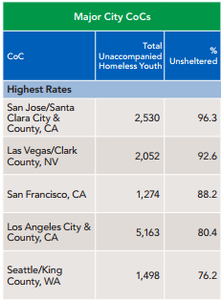

Total Homeless Unaccompanied Children and Youth on a Single Night in January 2017:
- California reported the largest numbers of unaccompanied homeless children and youth, at 15,458 people or 38% of the national total. It also had the second highest rate of unsheltered homeless children at 82.5% (12,749 were unsheltered), behind Nevada.
- California accounted for 58 percent of all unsheltered unaccompanied youth (12,749 people).
- California possesses the 3 of the top 5 major city CoC’s with the highest rate of unaccompanied homeless youth.

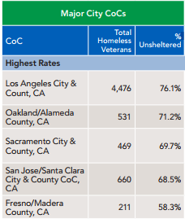

Total Homeless Veterans on a Single Night in January 2017:
- California had the largest number of veterans experiencing homelessness at 11,472. Homeless veterans in California represented 29% of the national homeless veteran population. California also had the third highest rate of unsheltered veterans at 66.7% (7,657 were unsheltered).
- Homelessness among veterans had declined most dramatically in California, where the number fell by 6,501 people (15%) since 2009.
- California possesses the 5 of the top 5 major city CoC’s with the highest rate of veterans homeless.

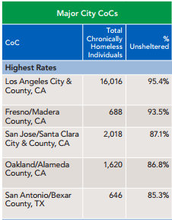
Total Chronically Homeless on a Single Night in January 2017:
- Forty-two percent of the nation’s chronically homeless population was located in California, at 35,798. California also had the second highest rate of unsheltered chronically homeless, at 87.6% (31,368 were unsheltered).
- California by far had the largest increase, with 5,996 more chronically homeless individuals in 2017 than in 2016. Over time, however, California experienced the largest decline in the number of chronically homeless individuals, with 4,543 fewer chronically homeless individuals in 2017 than in 2007.
- California possesses the 4 of the top 5 major city CoC’s with the highest rate of chronically homeless.

2017 Annual Homeless Assessment Report to Congress. U.S. Department of Housing and Urban Development. December 2017. https://www.hudexchange.info/resources/documents/2017-AHAR-Part-1.pdf
Continuums of Care (CoC) are local planning bodies responsible for coordinating the full range of homelessness services in a geographic area, which may cover a city, county, metropolitan area, or an entire state.

