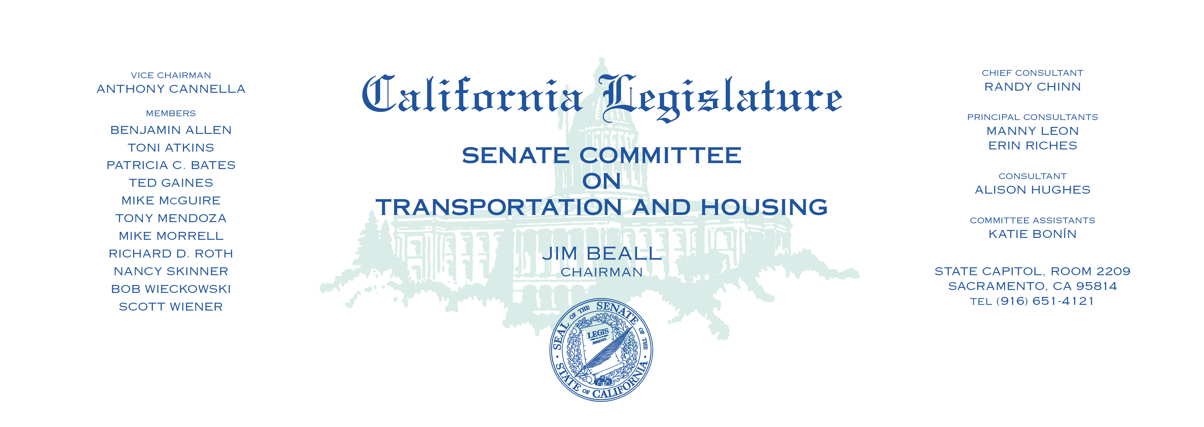

Tuesday, February 28, 2017

1:30 p.m. — John L. Burton Hearing Room (4203)

**AGENDA**

**_____________________________________________________**

1. S.B. 2 Atkins Building Homes and Jobs Act.
2. S.B. 3 Beall Affordable Housing Bond Act of 2018.
3. S.B. 35 Wiener Planning and Zoning: affordable housing:

streamlined approval process.

1. A.B. 28 Frazier Department of Transportation: environmental review

process: federal pilot program.