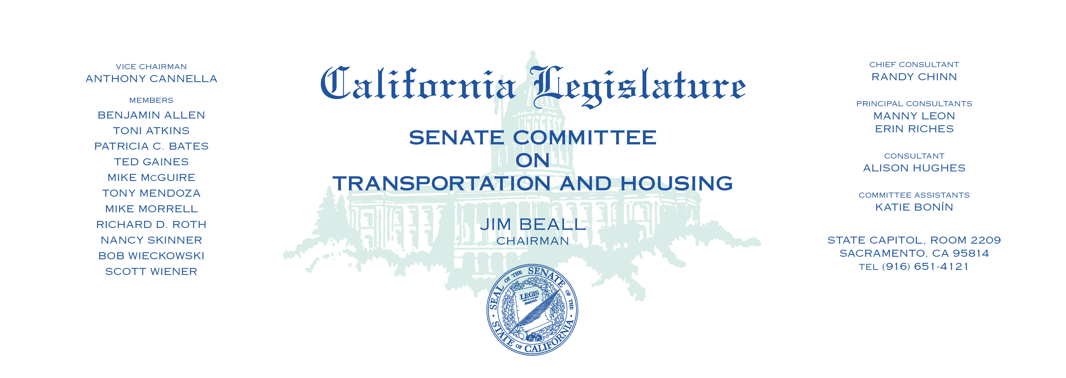

Tuesday, February 14, 2017

1:30 p.m. — John L. Burton Hearing Room (4203)

**AGENDA**

**_____________________________________________________**

ADOPTION OF COMMITTEE RULES AND POLICIES

1. S.B. 1 Beall Transportation funding.