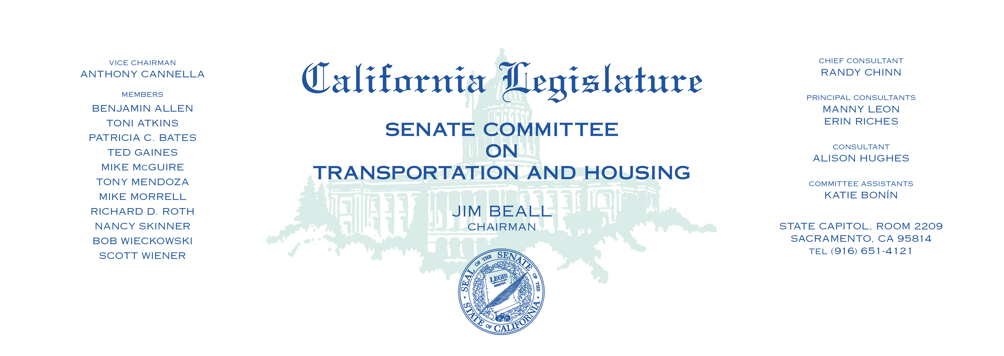

Tuesday, January 9, 2018

1:30 p.m. — John L. Burton Hearing Room (4203)

Items on consent are indicated by *

**AGENDA**

**_____________________________________________________**

1. S.B. 414 Vidak Transportation bonds: highway, street,

and road projects.

1. S.B. 712 Anderson Vehicles: license plate covers.
2. S.B. 760 Wiener Transportation funding: active transportation:

complete streets.

1. S.B. Holding* Portantino Surplus residential property: State Route 710:

property taxes: assessments. (Tax Levy)