A community school is both a place and a set of partnerships between the school and other community resources. Its integrated focus on academics, health and social services, youth and community development, and community engagement leads to improved student learning, stronger families, and healthier communities. Community schools offer a curriculum that emphasizes real-world learning and community problem-solving. Schools become centers of the community and are open to everyone – all day, every day, evenings, and weekends.

Community Schools are results focused:

- Students are healthy - physically, socially, and emotionally
- Students live and learn in a safe, supportive, and stable environment
- Schools are engaged with families and communities
- The communities are desirable places to live

- Children are ready to enter school and attend school consistently
- Students are actively involved in learning and their community
- Families are involved with their children's education
- Students succeed academically

Or think about community schools this way…
The Conventional School Model
Most people think of schools today as serving a single purpose: a binary, analog-system of delivery - teachers teach and students learn.
Community schools are more akin to smart phones. Schools and communities connect, collaborate, and create. Children and families have an array of supports from community partners right at their school.
Communities and schools leverage their shared physical and human assets to help kids succeed.
Community schools contain a host of built-in opportunities and supports that give students and parents all the tools they need to learn and grow.

Community Schools are Smart Schools

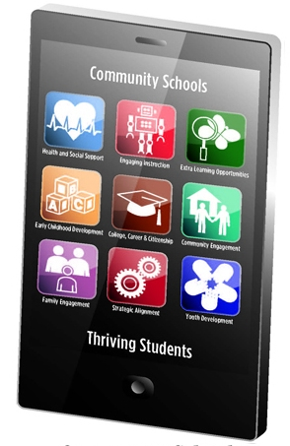

College, Career and Citizenship | Health & Social  Support | Expanded Learning Opportunities | Engaging  Instruction
Early Childhood Development | Community  Engagement | Family  Engagement | Youth  Development
Strategic Alignment
Just like smart phones, community schools have an infrastructure (or operating system) that strategically aligns 'apps' so they work in a synchronized manner. A school-site leadership team, often comprised of educators, parents, community partners, and others, is responsible for creating a shared vision for the school, identifying desired results and helping align and integrate the work of partners with the school. A community school coordinator works hand-in-hand with a supportive principal, and is a member of the school leadership team. The coordinator is responsible for building relationships with school staff and community partners, for engaging the families and community residents, and coordinating an efficient delivery of supports to students both inside and outside the classroom. Data on academic AND non-academic factors drive the work for a community school.
COMMUNITY SCHOOL ‘APPS’

The Coalition for Community Schools is an alliance of national, state and local organizations in education K‐16, youth development, community planning and development, family support, health and human services, government and philanthropy as well as national, state and local community school networks. Our mission is to advance opportunities for the success of children, families and communities by promoting the development of more, and more effective, community schools. The Coalition for Community Schools believes that strong communities require strong schools and strong schools require strong communities. We envision a future in which schools are centers of thriving communities where everyone belongs, works together, and succeeds. The Coalition is staffed by the Institute for Educational Leadership in Washington, DC

