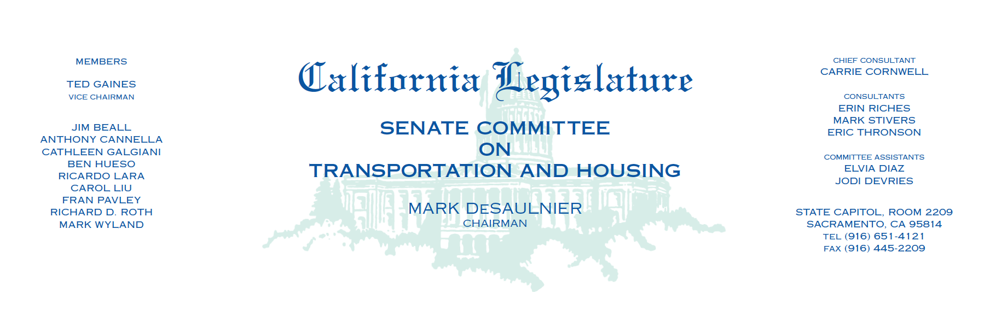

INFORMATIONAL HEARING

**BAY BRIDGE LESSONS LEARNED: RECEIPT OF FINAL REPORTS**

Tuesday, August 5, 2014

1:30 p.m. – John L. Burton Hearing Room (4203)

**AGENDA**

**I. Opening Remarks** – Chairman DeSaulnier

**II. Caltrans’ Lessons Learned Report**

Brian P. Kelly, Secretary – California State Transportation Agency

Frieder Seible, Member – Toll Bridge Seismic Safety Peer Review Panel

Brian Maroney, Toll Bridge Program Chief Engineer – California Department of Transportation

Brian Petersen, Project Manager – American Bridge/Fluor Joint Venture

Alvaro J. Piedrahita, P.E., President and CEO – T.Y. Lin International

Eric A. Nichol, Ph.D, P.E., President – Moffatt & Nichol

Malcolm Dougherty, Director – California Department of Transportation

**III. Bay Bridge Replacement Span Expert Panel Report**

Reginald DesRoches, Professor – Georgia Institute of Technology

Robert Leon, Professor – Virginia Polytechnic Institute and State University

Sena Kumarasena, Practicing Bridge Engineer

**IV. The De Wolk Report**

Keith Devonport, Chartered Engineer, Senior Member of The Welding Institute (Retired)

Nathan Lindell, Corporate Quality Manager – Oregon Iron Works, Inc.

Christopher Bakes, Partner – Locke Lord LLP

**V. Public Comment**