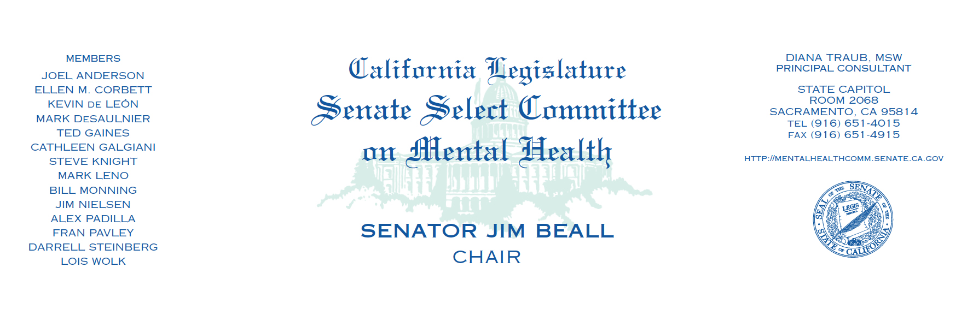
CALIFORNIA STATE SENATE
SELECT COMMITTEE ON MENTAL HEALTH HEARING

Every life Matters: Implementing Effective Suicide Prevention Strategies in California”
Tuesday, September 24th
1:00pm-3:00pm
San Francisco State Building
Milton Marks Auditorium
455 Golden Gate Avenue, San Francisco CA 94102

Opening Remarks

- Senator Jim Beall, Chair
- Senator Mark Leno
- Senator Ellen Corbett
- Assemblymember Tom Ammiano
- Assemblymember Ting

Special Presentations

- San Francisco Suicide Prevention
- Kevin Briggs, Sergeant, California Highway Patrol (Marin County)

Panel 1: Personal Testimony

- Kevin Hines, Suicide Survivor, Author of Cracked Not Broken
- Victor Ojakian, Suicide Prevention Advocate

Panel 2: State Agencies

- Kevin Briggs, Sergeant, California Highway Patrol
- Kevin Berthia – Suicide Survivor
- Department of Health Care Services, Suicide Prevention program

Panel 3: Research

- Rajeev Ramchand, Senior Behavioral and Social Scientist; Professor, RAND Corporation

Panel 4: Student Mental Health

- Spencer Wilson, Student, Novato High School on behalf of CalMHSA
- Nicola Survanshi, Director of ReachOut CA, Inspire USA Foundation
- Michelle Thomas, Youth Director, San Francisco Suicide Prevention
- Lilyana Gonzales Hudson, Youth Program Coordinator, San Francisco Suicide Prevention

Public Comment

Closing

