Joint Legislative INFORMATIONAL Hearing

2009 San Francisco-Oakland Bay Bridge Closures
and Related Bridge Safety Issues

BACKGROUND

Senate Transportation and Housing Committee
Senator Alan Lowenthal, Chair

Senate Select Committee on Bay Area Transportation
Senator Mark Leno, Chair

Senate Budget and Fiscal Review Sub-Committee No. 2 on
Resources, Environmental Protection, Energy and Transportation
Senator Joe Simitian, Chair

Assembly Transportation Committee
Assemblymember Mike Eng, Chair

January 12, 2009
Sacramento, CA

The purpose of today’s informational hearing is to provide the California Department of Transportation (Caltrans) an opportunity to report on the status of the structural integrity of east span of the San Francisco-Oakland Bay Bridge, and other state bridges of a similar design, as well as local bridges that incorporate design features similar to those found on the state bridges. The common structural feature of all the bridges is the incorporation of eyebars in the bridges.

An eyebar is a long steel plate having large circular ends with an "eye" or hole through which a pin is used to connect to other eyebars (to make a chain) or to other structural members of a bridge. The pins are held in place with bolted cap plates. In the case of the Bay Bridge the eyebar chains are used in conjunction with ridged structural members, which enhance the bridge’s structural integrity by creating redundancy.

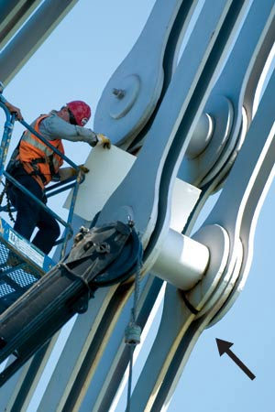

In the above picture, the arrow points to the crack in the Bay Bridge, which is clearly visible, that was discovered over the Labor Day weekend last September. The pin above the crack holds together eight eyebars, four on each end of the pin. Above the workman’s head, the bolted cap plate that holds the pins in place for another eyebar assembly is visible. The eyebars are forged steel components.

After an eyebar suspension bridge joining Ohio and West Virginia collapsed in 1967 resulting in the death of 46 persons, the Federal Highway Administration (FHWA) forbade the construction of bridges incorporating eyebars into their design and, beginning in 1971, mandated the states to inspect all bridges at least once every two years and report the data to the FHWA. With the data collected by the states, the FHWA has created a national data base that includes the safety rating for every bridge in the country. States must participate in this program to receive federal funds. The data collected by Caltrans’ inspectors exceeds the requirements of the federal program. Caltrans database on bridges in the state is quite extensive and includes the findings and notes of the inspectors, the results of any inspections enhanced by the use of technology and photographic documentation

Chronology of Events Related to the Bay Bridge Eyebar Failure

The chronology of 2009 events that led to this discovery of the cracked eyebar in the Bay Bridge and subsequent actions to repair the crack is as follows:

- September 3rd to September 8th the Bay Bridge is closed to modify the approach of the bridge to the Yerba Buena Tunnel to facilitate the construction of the new bridge. The cracked eyebar was discovered during the inspection of the bridge scheduled to occur during the closure.

- September 8th the repair of the cracked eyebar and the modification of the bridge for construction purposes are completed and bridge reopened to traffic at 7am only two hours later than scheduled. The repair to the eyebar was not peer reviewed.

- October 27th high winds cause the repaired eyebar to break at 5:30pm and fall to westbound bridge deck during the afternoon commute. Three vehicles were damaged and one person injured. The bridge was closed.

- November 2nd the bridge is reopened after a temporary “fix” is made to the original eyebar repaired. This repair is peer reviewed.

- December 11th long-term repair to the eyebar begins. The repair entails cutting and removing approximately 12 feet of the cracked eyebar, and replacing it with new structural steel that will be spliced into the remainder of the existing eyebar. The bridge remained opened during the repair, although there were lane closures.

- December 29th long-term repair to the cracked eyebar completed after extensive peer review and the bridge is reopened to traffic.

Between December 11th and December 29th a permanent repair was designed, fabricated, and installed. The diagram below shows in sequence the repairs that were made. Essentially, the cracked steel was replaced by a new section of steel which was spliced into the eyebar and the head of the eyebar located above the crack was removed and a new piece of steel, referred to as a “hairpin”, was fabricated to replace the eye through which the pin is inserted that holds the assembly of eight eyebars together.

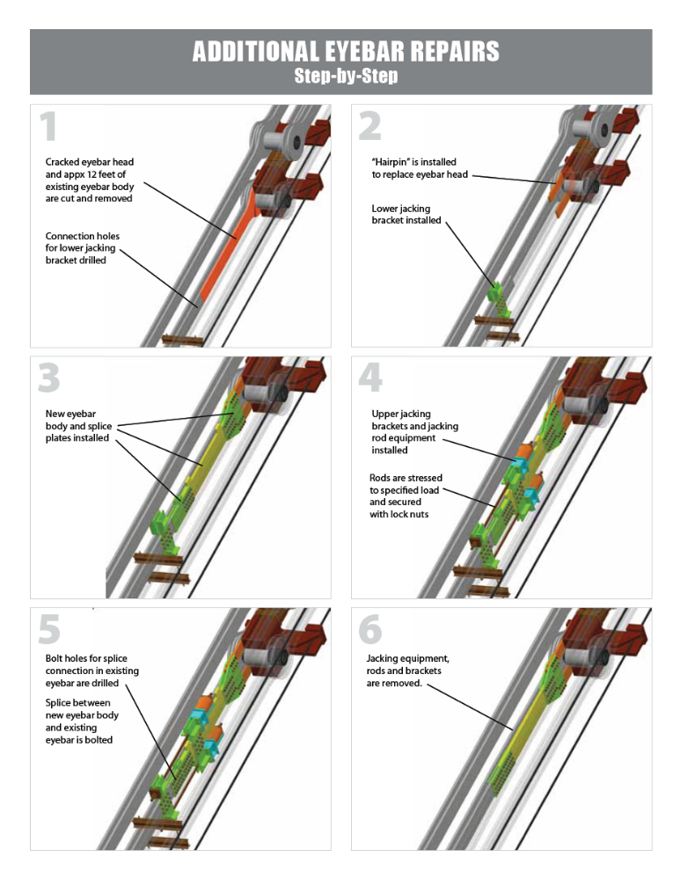

Questions for Caltrans Regarding the Bay Bridge

Randall H. Iwasaki, Director of Caltrans, supported by the appropriate staff, will testify on the status of the Bay Bridge repair and safety program. Mr. Iwasaki will address the following questions:

- What were the circumstances that led to the discovery of the failed eyebar during the Labor Day Closure of the Bay Bridge? What is the frequency of bridge inspections? Do the age of the bridge, the degree of structural redundancy engineered into a bridge’s design, a bridge’s proximity to an active fault zone, and other similar factors influence the frequency of inspections?

- What were the causes of the eyebar failure? Since the eyebars were fabricated at the approximately the same time during the construction of the Bridge between 1933 and 1936, what is being done to ensure that the remaining eyebars are not affected by the same causes?

- What caused the temporary “fix” fabricated over the Labor Day weekend to fail on October 27, 2009? Did Caltrans inspectors notice unanticipated movement in the temporary fix prior to its failure? If so, in retrospect, should Caltrans have acted to close the bridge or close a traffic lane when the motion was detected?

- What steps are being taken to ensure the integrity of the 1,680 eyebars on the east span of the Bay Bridge? Explain the new inspection protocols that Caltrans has instituted on the Bay Bridge?

- What does Caltrans estimate the total cost of repairing the failed eyebar (including the Labor Day repair and subsequent related repairs), enhanced inspection for the remainder of the Bridge’s life, and the deployment of any monitoring technology to be?

- Are staff redirection and furloughs reducing the time spent on overall bridge inspection on both state and local bridges, perhaps endangering the public? Are toll revenues used to pay for toll bridge inspectors?

- The Richmond-San Rafael Bridge incorporates non-load bearing eyebars in its design. In light of the Bay Bridge experience, what is being done to ensure the integrity of its eyebars? Similarly, eyebars are incorporated in the design of the west span (suspension span) of the Bay Bridge, what is being done to ensure the integrity of its eyebars? Will remote sensing technology be installed in these two high volume bridges?

- What is the division of responsibility between Caltrans and Metropolitan Transportation Commission in regard to the state owned bridges in the Bay Area?

Local Bridges with Eyebar Components

In addition to the four state bridges in which eyebar suspension elements are incorporated, there are 52 local bridges that include eyebars in there design. Table 1 lists both the state and local eyebar bridges. The column headings are generally self-explanatory. However ADT refers to average daily traffic. Structurally deficient, functionally obsolete, and sufficiency rating are closely related terms that need some explanation.

Terms Used in Discussing Condition of Bridges

Structurally Deficient Bridge

A structurally deficient (SD) bridge typically requires significant maintenance and repair to remain in service and eventual rehabilitation or replacement to address deficiencies. Examples of poor conditions include corrosion that has caused significant loss of strength in steel support members, cracks in the bridge decking or other concrete components, movement in columns and piers, or if the bridge deck or the road approaches to a bridge are frequently overtopped with water from the stream below. Another condition that may result in a bridge being structurally deficient is if it is unable to carry the weights it was designed to support, resulting in posted weight limits to restrict the gross weight of vehicles using a bridge.

Functionally Obsolete Bridge

A functionally obsolete (FO) bridge is one that was built to standards that are not used today. It may have inadequate lane and shoulder widths, vertical clearances may be too low, or the alignment of the bridge approach road may have inappropriate curvature, resulting in major speed reductions.

Fracture-Critical Bridge

A fracture-critical bridge is one that does not contain redundant structural elements. Because of the lack of redundancy, if a key support fails the bridge would be in danger of collapse. As long as a fracture critical bridge is inspected and maintained, if should function safely.

Sufficiency Rating

The findings of a bridge inspection are used to create a sufficiency rating. The terms of the sufficiency rating are defined by the FHWA. The formula places 55 percent value on the structural condition of the bridge, 30 percent on a bridge’s serviceability and obsolescence, and 15 percent on its importance to public use. The point calculation is based on a 0-100 scale, with 0 meaning a bridge is very dangerous and should be closed. A new bridge, designed to contemporary standards would be rated 100.

All bridges go through a natural deterioration or aging process due to use and the fatigue of the materials from which is constructed. In addition, bridge design standards change and at some point in the life of a bridge its design is substandard.

The following table identifies the nature of a bridge’s deficiencies and its sufficiency rating. Aside from the first four bridges, all the bridges in the table are owned by cities and counties. Most of the bridges were constructed in the first half of the twentieth century and have low traffic volumes, with the oldest crossing Burger Creek in Mendocino County and serving 100 vehicles per day.

Questions to Caltrans Regarding Local Bridges

- Caltrans inspects local bridges in all of the state’s counties, expect for Los Angeles and Santa Clara counties. There are 52 local bridges that incorporate eyebars in their design. Most of these bridges date from the first half of the twentieth century (one actually dates from 1888), and most of the bridges experience low traffic volumes. How frequently are these bridges inspected? Are there any that warrant more frequent inspections? Are any of these bridges fracture critical?

- Six of the local bridges carry over 1,000 vehicles per day. Can Caltrans warrant that these bridges have no know structural deficiencies? Do these bridges have any speed limits or weight limits imposed on them because of their design or structural condition? Do they require any special inspection routines, including any related to the incorporation of an eyebar system in their design? Are any of these bridges fracture critical?

Table 1

State and Local Bridges that Include Eyebars in Their Construction
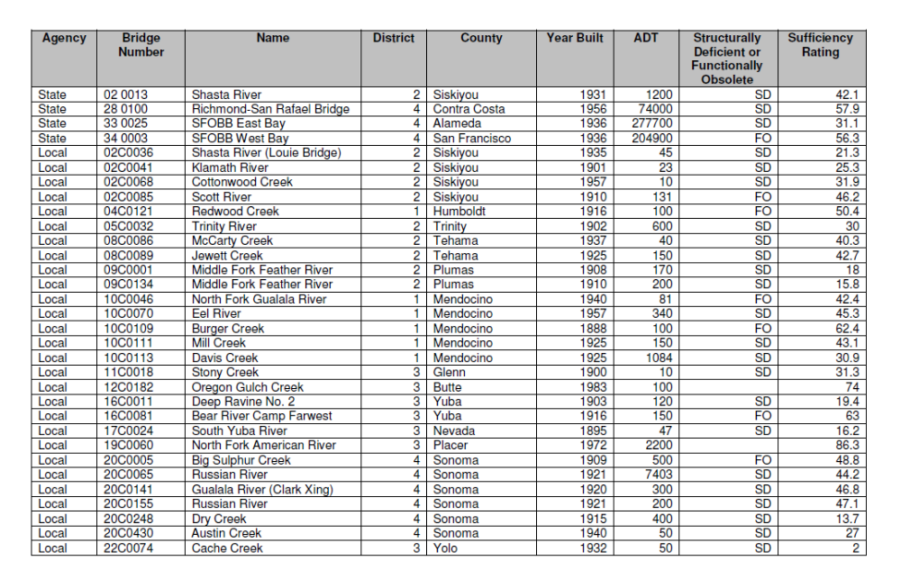

Table 1 con’t

State and Local Bridges that Include Eyebars in Their Construction



